# Chapter 6 - Google Cloud Run Serverless Workshop

# Build a Serverless App with Cloud Run that Creates PDF Files

1 hourFree

## GSP644





## Overview

For the labs in the [GCP Serverless Workshop: Pet Theory Quest](https://google.qwiklabs.com/quests/98), you will read through a fictitious business scenario and assist the characters with their serverless migration plan.

Twelve years ago, Lily started the Pet Theory chain of veterinary clinics. Pet Theory currently sends invoices in DOCX format to clients, but many clients have complained that they are unable to open them. To improve customer satisfaction, Lily has asked Patrick in IT to investigate an alternative to improve the current situation.

Pet Theory's Ops team is a single person, so they are keen to invest in a cost efficient solution that doesn't require a lot of ongoing maintenance. After analyzing the various processing options, Patrick decides to use [Cloud Run](https://cloud.google.com/run/).

Cloud Run is serverless, so it abstracts away all infrastructure management and lets you focus on building your application instead of worrying about overhead. As a Google serverless product, it is able to scale to zero, meaning it won't incur cost when not used. It also lets you use custom binary packages based on containers, which means building consistent isolated artifacts is now feasible.

In this lab you will build a PDF converter web app on Cloud Run that automatically converts files stored in Cloud Storage into PDFs stored in seperated folders.

### **Architecture**

This diagram gives you an overview of the services you will be using and how they connect to one another:

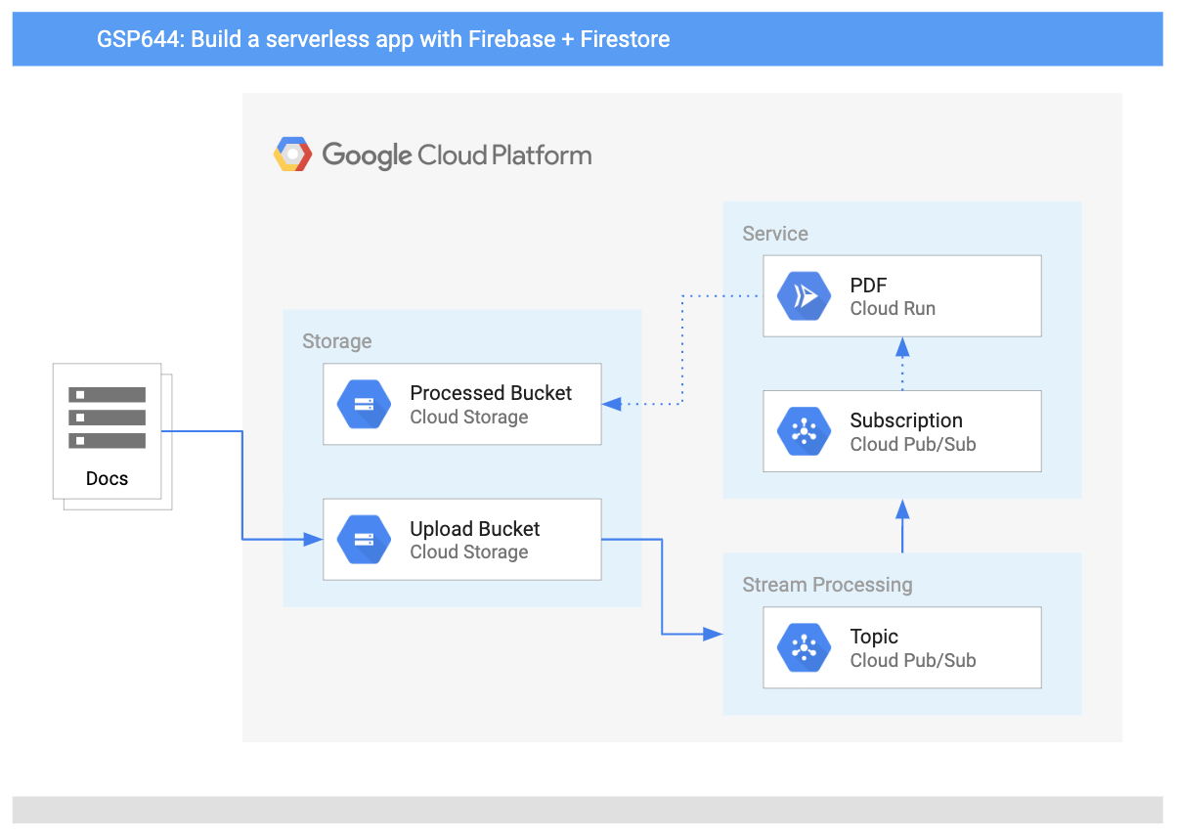

### **What you will learn**

In this lab, you will learn how to:

* Convert a Node JS application to a container.
* Build containers with Google Cloud Build.
* Create a Cloud Run service that converts files to PDF files in the cloud.
* Use event processing with Google Cloud Storage

### **Prerequisites**

This is a **fundamental level** lab. This assumes familiarity with the GCP Console and shell environments. Experience with Firebase will be helpful, but it is not required. Before taking this lab it is recommended that you have completed the following Qwiklabs before taking this one:

* [Migrating Data to a Firestore Database](https://google.qwiklabs.com/catalog_lab/2163)
* [Build a Serverless Web App with Firebase and Firestore](https://google.qwiklabs.com/catalog_lab/2166)

You should also be comfortable editing files. You can use your favorite text editor (like nano, vi, etc.) or you can launch the code editor from Cloud Shell, which can be found in the top ribbon:



Once you're ready, scroll down and follow the steps below to setup your lab environment.

## Setup and Requirements

#### Before you click the Start Lab button

Read these instructions. Labs are timed and you cannot pause them. The timer, which starts when you click **Start Lab**, shows how long Google Cloud resources will be made available to you.

This Qwiklabs hands-on lab lets you do the lab activities yourself in a real cloud environment, not in a simulation or demo environment. It does so by giving you new, temporary credentials that you use to sign in and access Google Cloud for the duration of the lab.

#### What you need

To complete this lab, you need:

* Access to a standard internet browser (Chrome browser recommended).
* Time to complete the lab.

**Note:** If you already have your own personal Google Cloud account or project, do not use it for this lab.

**Note:** If you are using a Pixelbook, open an Incognito window to run this lab.

#### How to start your lab and sign in to the Google Cloud Console

1. Click the **Start Lab** button. If you need to pay for the lab, a pop-up opens for you to select your payment method. On the left is a panel populated with the temporary credentials that you must use for this lab.

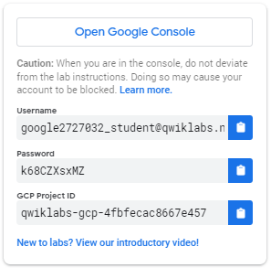

1. Copy the username, and then click **Open Google Console**. The lab spins up resources, and then opens another tab that shows the **Sign in** page.

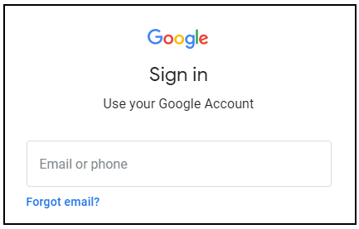

**Tip:** Open the tabs in separate windows, side-by-side.

If you see the **Choose an account** page, click **Use Another Account**. 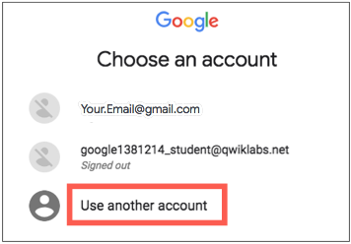

1. In the **Sign in** page, paste the username that you copied from the Connection Details panel. Then copy and paste the password.

**Important:** You must use the credentials from the Connection Details panel. Do not use your Qwiklabs credentials. If you have your own Google Cloud account, do not use it for this lab (avoids incurring charges).

1. Click through the subsequent pages:
   * Accept the terms and conditions.
   * Do not add recovery options or two-factor authentication (because this is a temporary account).
   * Do not sign up for free trials.

After a few moments, the Cloud Console opens in this tab.

**Note:** You can view the menu with a list of Google Cloud Products and Services by clicking the **Navigation menu** at the top-left. 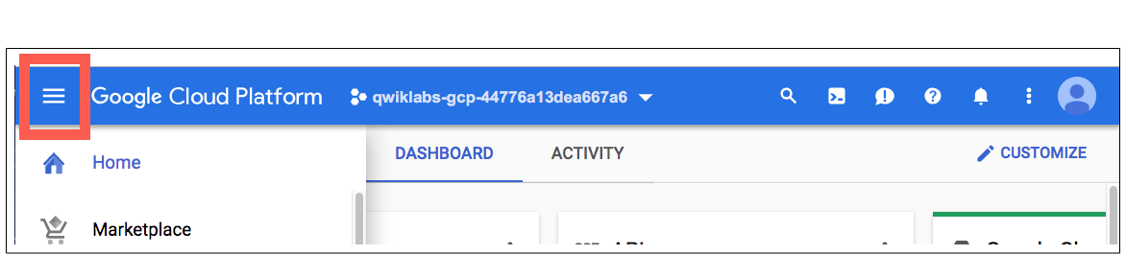

### **Activate Cloud Shell**

Cloud Shell is a virtual machine that is loaded with development tools. It offers a persistent 5GB home directory and runs on the Google Cloud. Cloud Shell provides command-line access to your Google Cloud resources.

In the Cloud Console, in the top right toolbar, click the **Activate Cloud Shell** button.

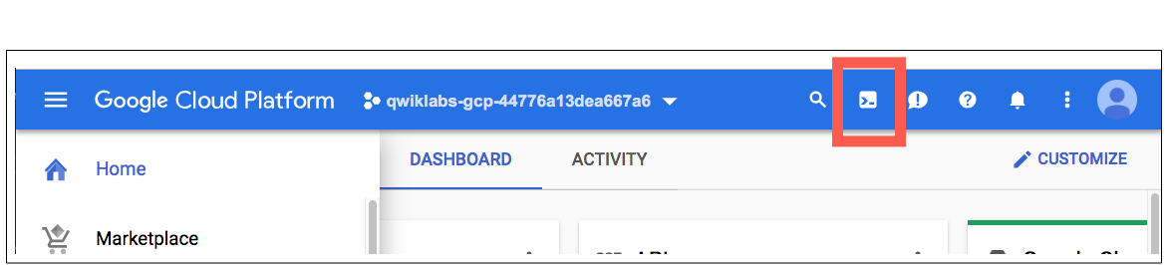

Click **Continue**.

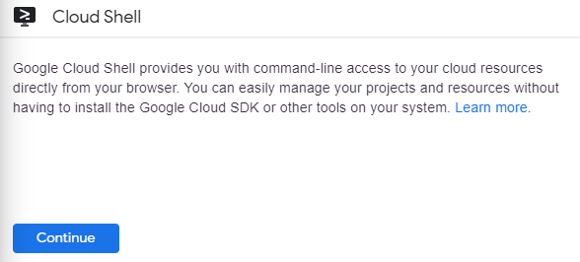

It takes a few moments to provision and connect to the environment. When you are connected, you are already authenticated, and the project is set to your PROJECT_ID. For example:

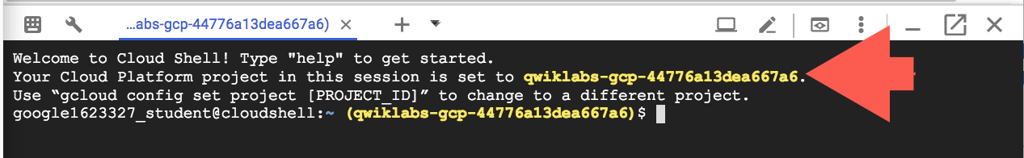

gcloud is the command-line tool for Google Cloud. It comes pre-installed on Cloud Shell and supports tab-completion.

You can list the active account name with this command:

gcloud auth list

content_copy

(Output)

Credentialed accounts:

- <myaccount>@<mydomain>.com (active)content_copy

(Example output)

Credentialed accounts:

- google1623327_student@qwiklabs.netcontent_copy

You can list the project ID with this command:

gcloud config list project

content_copy

(Output)

[core]

project = <project_ID>content_copy

(Example output)

[core]

project = qwiklabs-gcp-44776a13dea667a6content_copy

For full documentation of gcloud see the [gcloud command-line tool overview](https://cloud.google.com/sdk/gcloud).

## Understanding the task

Pet theory would like to convert their invoices into PDFs so that customers can open them reliably. The team wants to accomplish this conversion automatically to minimize the workload for Lisa, the office manager.

Ruby, Pet Theory's computer consultant, gets a message from Patrick in IT...

|  |  |
| --- | --- |
| image  Patrick, IT Administrator | Hi Ruby,  I've done some research and found that [LibreOffice](https://www.libreoffice.org/) is good at converting many different file formats to PDF.  Would it be possible to run LibreOffice in the cloud without having to maintain the servers?  Patrick |
| imageRuby, Software Consultant | Hey Patrick,  I think I have just the thing for this type of situation.  I just watched a great video from Next 19 about [Cloud Run](https://youtu.be/16vANkKxoAU?t=1317) on YouTube. It looks like we can run LibreOffice in a serverless environment with Cloud Run. No server maintenance is needed!  I'll send over some resources that will help you get set up.  Ruby |

Help Patrick set up and deploy Cloud Run.

## Enable the Cloud Run API

1. Open the navigation menu and select **APIs & Services** > **Library**. Then in the search bar, enter in "Cloud Run" and select the Cloud Run API from the results list.
2. Click **Enable** and then hit the back button in your browser twice. Your Console should now resemble the following:

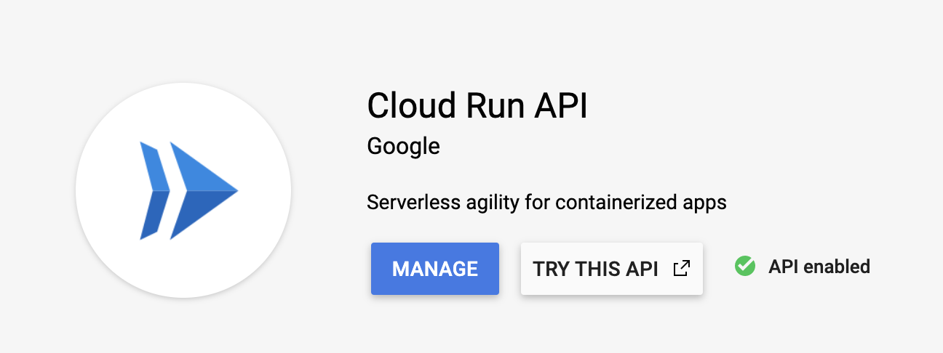

## Deploy a simple Cloud Run service

Ruby has developed a Cloud Run prototype and would like Patrick to deploy it onto GCP. Now help Patrick establish the PDF Cloud Run service for Pet Theory.

1. Open a new Cloud Shell session and run the following command to clone the Pet Theory repository:

git clone https://github.com/rosera/pet-theory.git

content_copy

1. Then change your current working directory to lab03:

cd pet-theory/lab03

content_copy

1. Edit package.json with Cloud Shell Code Editor or your preferred text editor. In the "scripts" section, add "start": "node index.js", as shown below:

...

"scripts": {

"start": "node index.js",

"test": "echo \"Error: no test specified\" && exit 1"

},

...

content_copy

1. Now run the following commands in Cloud Shell to install the packages that your conversion script will be using:

npm install express

npm install body-parser

npm install child_process

npm install @google-cloud/storage

content_copy

1. Now open the lab03/index.js file and review the code.

The application will be deployed as a Cloud Run service that accepts HTTP POSTs. If the POST request is a Pub/Sub notification about an uploaded file, the service writes the file details to the log. If not, the service simply returns the string "OK".

1. Review the file named lab03/Dockerfile.

The above file is called a manifest and provides a recipe for the Docker command to build an image. Each line begins with a command that tells Docker how to process the following information:

* The first list indicates the base image should use node v12 as the template for the image to be created.
* The last line indicates the command to be performed, which in this instance refers to "npm start".

1. To build and deploy the REST API, use Google Cloud Build. Run this command to start the build process:

gcloud builds submit \

--tag gcr.io/$GOOGLE_CLOUD_PROJECT/pdf-converter

content_copy

The command builds a container with your code and puts it in the Container Registry of your project.

1. Return to the GCP Console, open the navigation menu, and select **Container Registry** > **Images**. You should see your container hosted:

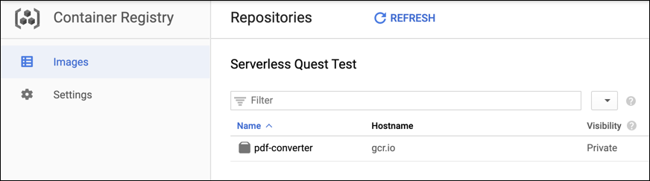

### **Test Completed Task**

Click **Check my progress** to verify that you've performed the above task.

Build simple a REST API

Check my progress

1. Return to your code editor tab and in Cloud Shell run the following command to deploy your application:

gcloud beta run deploy pdf-converter \

--image gcr.io/$GOOGLE_CLOUD_PROJECT/pdf-converter \

--platform managed \

--region us-central1 \

--no-allow-unauthenticated

content_copy

1. When the deployment is complete, you will see a message like this:

Service [pdf-converter] revision [pdf-converter-00001] has been deployed and is serving 100 percent of traffic at https:*//pdf-converter-[hash].a.run.app*content_copy

1. Create the environment variable $SERVICE_URL for the app so you can easily access it:

SERVICE_URL=$(gcloud beta run services describe pdf-converter --platform managed --region us-central1 --format="value(status.url)")

content_copy

echo $SERVICE_URL

content_copy

### **Test Completed Task**

Click **Check my progress** to verify that you've performed the above task.

Create a Revision for Cloud Run

Check my progress

1. Make an anonymous POST request to your new service:

curl -X POST $SERVICE_URL

content_copy

This will result in an error message saying "Your client does not have permission to get the URL". This is good; you don't want the service to be callable by anonymous users.

1. Now try invoking the service as an authorized user:

curl -X POST -H "Authorization: Bearer $(gcloud auth print-identity-token)" $SERVICE_URL

content_copy

If you get the response "OK" you have successfully deployed a Cloud Run service. Well done!

## Trigger your Cloud Run service when a new file is uploaded

Now that the Cloud Run service has been successfully deployed, Ruby would like Patrick to create a staging area for the data to be converted. The Google Cloud Storage bucket will use an event trigger to notify the application when a file has been uploaded and needs to be processed.

1. Run the following command to create a bucket in Cloud Storage for the uploaded docs:

gsutil mb gs://$GOOGLE_CLOUD_PROJECT-upload

content_copy

1. And another bucker for the processed PDFs:

gsutil mb gs://$GOOGLE_CLOUD_PROJECT-processed

content_copy

1. Now return to your GCP Console tab, open the **Navigation menu** and select **Storage**. Verify that the buckets have been created (there will be other buckets there as well that are used by the platform.)

### **Test Completed Task**

Click **Check my progress** to verify that you've performed the above task.

Create two cloud storage buckets

Check my progress

1. In Cloud Shell run the following command to tell Cloud Storage to send a Pub/Sub notification whenever a new file has finished uploading to the docs bucket:

gsutil notification create -t new-doc -f json -e OBJECT_FINALIZE gs://$GOOGLE_CLOUD_PROJECT-upload

content_copy

The notifications will be labeled with the topic "new-doc".

### **Test Completed Task**

Click **Check my progress** to verify that you've performed the above task.

Create a Pub/Sub topic for handling notifications from storage bucket

Check my progress

1. Then create a new service account which Pub/Sub will use to trigger the Cloud Run services:

gcloud iam service-accounts create pubsub-cloud-run-invoker --display-name "PubSub Cloud Run Invoker"

content_copy

1. Give the new service account permission to invoke the PDF converter service:

gcloud beta run services add-iam-policy-binding pdf-converter --member=serviceAccount:pubsub-cloud-run-invoker@$GOOGLE_CLOUD_PROJECT.iam.gserviceaccount.com --role=roles/run.invoker --platform managed --region us-central1

content_copy

1. Find your project number by running this command:

gcloud projects list

content_copy

Look for the project whose name starts with "qwiklabs-gcp-". You will be using the value of the Project Number in the next command.

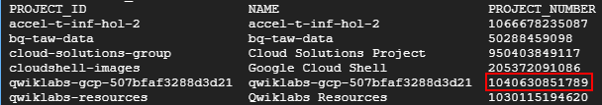

1. Create a PROJECT_NUMBER environment variable, replacing [project number] with the Project Number from the last command:

PROJECT_NUMBER=[project number]

content_copy

1. Then enable your project to create Cloud Pub/Sub authentication tokens:

gcloud projects add-iam-policy-binding $GOOGLE_CLOUD_PROJECT --member=serviceAccount:service-$PROJECT_NUMBER@gcp-sa-pubsub.iam.gserviceaccount.com --role=roles/iam.serviceAccountTokenCreator

content_copy

1. Finally, create a Pub/Sub subscription so that the PDF converter can run whenever a message is published on the topic "new-doc".

gcloud beta pubsub subscriptions create pdf-conv-sub --topic new-doc --push-endpoint=$SERVICE_URL --push-auth-service-account=pubsub-cloud-run-invoker@$GOOGLE_CLOUD_PROJECT.iam.gserviceaccount.com

content_copy

### **Test Completed Task**

Click **Check my progress** to verify that you've performed the above task.

Create a Pub/Sub subscription

Check my progress

## See if the Cloud Run service is triggered when files are uploaded to Cloud Storage

To verify the application is working as expected, Ruby asks Patrick to upload some test data to the named storage bucket and then check Cloud Logging.

1. Copy some test files into your upload bucket:

gsutil -m cp gs://spls/gsp644/* gs://$GOOGLE_CLOUD_PROJECT-upload

content_copy

1. Once the upload is done, return to your GCP Console tab, open the navigation menu, and select **Logging** from under the Operations section.
2. In the first dropdown, filter your results to **Cloud Run Revision**.
3. In the log results, look or a log entry that starts with file: and click it. It shows a dump of the file data that Pub/Sub sends to your Cloud Run service when a new file is uploaded.
4. Can you find the name of the file you uploaded in this object?

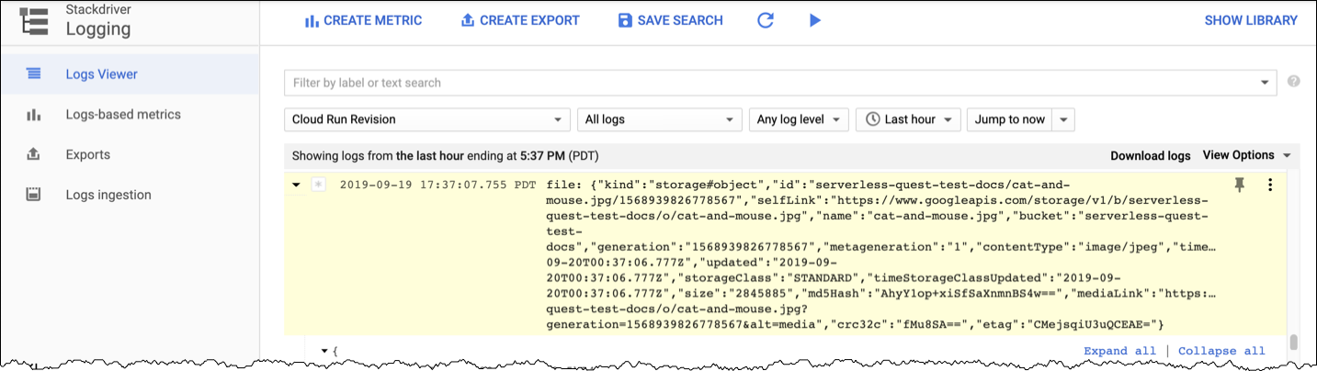

**Note:** If you do not see any log entries that begin with "file", try clicking on the "load newer logs" button near the bottom of the page.

1. Now return to the code editor tab and run the following command in Cloud Shell to clean up your upload directory by deleting the files in it:

gsutil -m rm gs://$GOOGLE_CLOUD_PROJECT-upload/*

content_copy

## Docker containers

Patrick needs to convert a backlog of invoices to PDFs so all customers can open them. He emails Ruby for some help...

|  |  |
| --- | --- |
| image  Patrick, IT Administrator | Hi Ruby  Based on your findings, I think we can automate this process and also move to using PDF as the invoice format.  I spent a bit of time yesterday coding a solution and built a Node.js script to do what we need. Could you take a look?  Patrick |

Patrick sends Ruby the code fragment he wrote to produce a PDF from a file:

const {promisify} = require('util');

const exec = promisify(require('child_process').exec);

const cmd = 'libreoffice --headless --convert-to pdf --outdir ' +

`/tmp "/tmp/${fileName}"`;

const { stdout, stderr } = await exec(cmd);

if (stderr) {

throw stderr;

}

content_copy

Ruby responds back to Patrick...

|  |  |
| --- | --- |
| image  Ruby, Software Consultant | Hi Patrick  Cloud Run uses containers, so we need to provide your application in this format. For the next step we need to create a [Dockerfile manifest](https://source.cloud.google.com/serverless-quest/labs/+/master:lab-3/Dockerfile?authuser=1) for the application.  Your code uses LibreOffice. Can you send me the command for installing that software? I will need to include it in the container.  Ruby |
| image  Patrick, IT Administrator | Hi Ruby  Awesome, here is how I usually install LibreOffice on servers in the office:  apt-get update -y && apt-get install -y libreoffice && apt-get clean  Let me know if you need any more information.  Patrick |

Building the container will require the integration of a number of components:

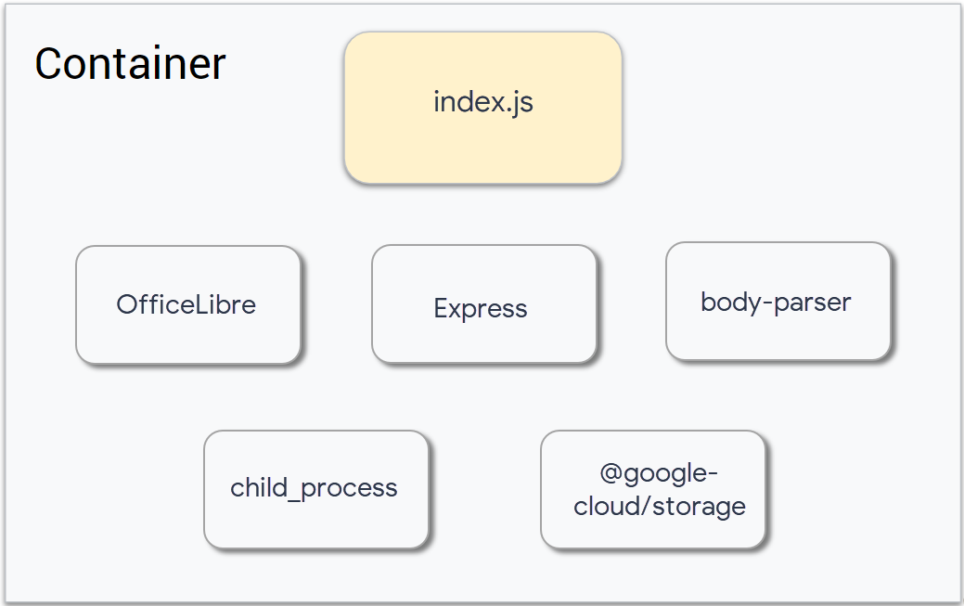

### **Update the Docker container**

With all the files identified, the Dockerfile can now be created. Help Ruby set up and deploy the container.

The package for LibreOffice was not included in the container before, which means it now needs to be added. Patrick has previously provided the commands he uses to build his application, Ruby will add these as a RUN command within the Dockerfile.

1. Open the Dockerfile manifest and add the command RUN apt-get update -y && apt-get install -y libreoffice && apt-get clean line as shown below:

FROM node:12

RUN apt-get update -y \

&& apt-get install -y libreoffice \

&& apt-get clean

WORKDIR /usr/src/app

COPY package.json package*.json ./

RUN npm install --only=production

COPY . .

CMD [ "npm", "start" ]

content_copy

### **Deploy the new version of the pdf-conversion service**

1. Open the index.js file and add the following package requirements at the top of the file:

const {promisify} = require('util');

const {Storage} = require('@google-cloud/storage');

const exec = promisify(require('child_process').exec);

const storage = new Storage();

content_copy

1. **Replace** the app.post('/', async (req, res) with the following code:

app.post('/', async (req, res) => {

try {

const file = decodeBase64Json(req.body.message.data);

await downloadFile(file.bucket, file.name);

const pdfFileName = await convertFile(file.name);

await uploadFile(process.env.PDF_BUCKET, pdfFileName);

await deleteFile(file.bucket, file.name);

}

catch (ex) {

console.log(`Error: ${ex}`);

}

res.set('Content-Type', 'text/plain');

res.send('\n\nOK\n\n');

})

content_copy

1. Now add the following code that processes LibreOffice documents to the bottom of the file:

async function downloadFile(bucketName, fileName) {

const options = {destination: `/tmp/${fileName}`};

await storage.bucket(bucketName).file(fileName).download(options);

}

async function convertFile(fileName) {

const cmd = 'libreoffice --headless --convert-to pdf --outdir /tmp ' +

`"/tmp/${fileName}"`;

console.log(cmd);

const { stdout, stderr } = await exec(cmd);

if (stderr) {

throw stderr;

}

console.log(stdout);

pdfFileName = fileName.replace(/\.\w+$/, '.pdf');

return pdfFileName;

}

async function deleteFile(bucketName, fileName) {

await storage.bucket(bucketName).file(fileName).delete();

}

async function uploadFile(bucketName, fileName) {

await storage.bucket(bucketName).upload(`/tmp/${fileName}`);

}

content_copy

1. Ensure your index.js file looks like the following:

const {promisify} = require('util');

const {Storage} = require('@google-cloud/storage');

const exec = promisify(require('child_process').exec);

const storage = new Storage();

const express = require('express');

const bodyParser = require('body-parser');

const app = express();

app.use(bodyParser.json());

const port = process.env.PORT || 8080;

app.listen(port, () => {

console.log('Listening on port', port);

});

app.post('/', async (req, res) => {

try {

const file = decodeBase64Json(req.body.message.data);

await downloadFile(file.bucket, file.name);

const pdfFileName = await convertFile(file.name);

await uploadFile(process.env.PDF_BUCKET, pdfFileName);

await deleteFile(file.bucket, file.name);

}

catch (ex) {

console.log(`Error: ${ex}`);

}

res.set('Content-Type', 'text/plain');

res.send('\n\nOK\n\n');

})

function decodeBase64Json(data) {

return JSON.parse(Buffer.from(data, 'base64').toString());

}

async function downloadFile(bucketName, fileName) {

const options = {destination: `/tmp/${fileName}`};

await storage.bucket(bucketName).file(fileName).download(options);

}

async function convertFile(fileName) {

const cmd = 'libreoffice --headless --convert-to pdf --outdir /tmp ' +

`"/tmp/${fileName}"`;

console.log(cmd);

const { stdout, stderr } = await exec(cmd);

if (stderr) {

throw stderr;

}

console.log(stdout);

pdfFileName = fileName.replace(/\.\w+$/, '.pdf');

return pdfFileName;

}

async function deleteFile(bucketName, fileName) {

await storage.bucket(bucketName).file(fileName).delete();

}

async function uploadFile(bucketName, fileName) {

await storage.bucket(bucketName).upload(`/tmp/${fileName}`);

}content_copy

1. The main logic is housed in these functions:

const file = decodeBase64Json(req.body.message.data);

await downloadFile(file.bucket, file.name);

const pdfFileName = await convertFile(file.name);

await uploadFile(process.env.PDF_BUCKET, pdfFileName);

await deleteFile(file.bucket, file.name);content_copy

Whenever a file has been uploaded, this service gets triggered. It performs these tasks, one per line above:

* Extracts the file details from the Pub/Sub notification.
* Downloads the file from Cloud Storage to the local hard drive. This is actually not a physical disk, but a section of virtual memory that behaves like a disk.
* Converts the downloaded file to PDF.
* Uploads the PDF file to Cloud Storage. The environment variable process.env.PDF_BUCKET contains the name of the Cloud Storage bucket to write PDFs to. You will assign a value to this variable when you deploy the service below.
* Deletes the original file from Cloud Storage.

The rest of index.js implements the functions called by this top-level code.

It's time to deploy the service, and to set the PDF_BUCKET environment variable. It's also a good idea to give LibreOffice 2 GB of RAM to work with (see the line with the --memory option).

1. Run the following command to build the container:

gcloud builds submit \

--tag gcr.io/$GOOGLE_CLOUD_PROJECT/pdf-converter

content_copy

### **Test Completed Task**

Click **Check my progress** to verify that you've performed the above task.

Create another build for REST API

Check my progress

1. Now deploy the latest version of your application:

gcloud beta run deploy pdf-converter \

--image gcr.io/$GOOGLE_CLOUD_PROJECT/pdf-converter \

--platform managed \

--region us-central1 \

--memory=2Gi \

--no-allow-unauthenticated \

--set-env-vars PDF_BUCKET=$GOOGLE_CLOUD_PROJECT-processed

content_copy

With LibreOffice part of the container, this build will take longer than the previous one. This is a good time to get up and stretch for a few minutes.

Click **Check my progress** to verify the objective.

Create a new Revision

Check my progress

## Testing the pdf-conversion service

1. Once the deployment commands finish, make sure that the service was deployed correctly by running:

curl -X POST -H "Authorization: Bearer $(gcloud auth print-identity-token)" $SERVICE_URL

content_copy

1. If you get the response "OK" you have successfully deployed the updated Cloud Run service. LibreOffice can convert many file types to PDF: DOCX, XLSX, JPG, PNG, GIF, etc.
2. Run the following command to upload some example files:

gsutil -m cp gs://spls/gsp644/* gs://$GOOGLE_CLOUD_PROJECT-upload

content_copy

1. Return to the GCP Console, open the **Navigation menu** and select **Storage**. Open the -upload bucket and click on the **Refresh bucket** button a couple of times to see how the files are deleted, one by one, as they are converted to PDFs.
2. Then click **Browser** from the left menu, and click on the bucket whose name ends in "-processed". It should contain PDF versions of all files. Feel free to open the PDF files to make sure they were properly converted:

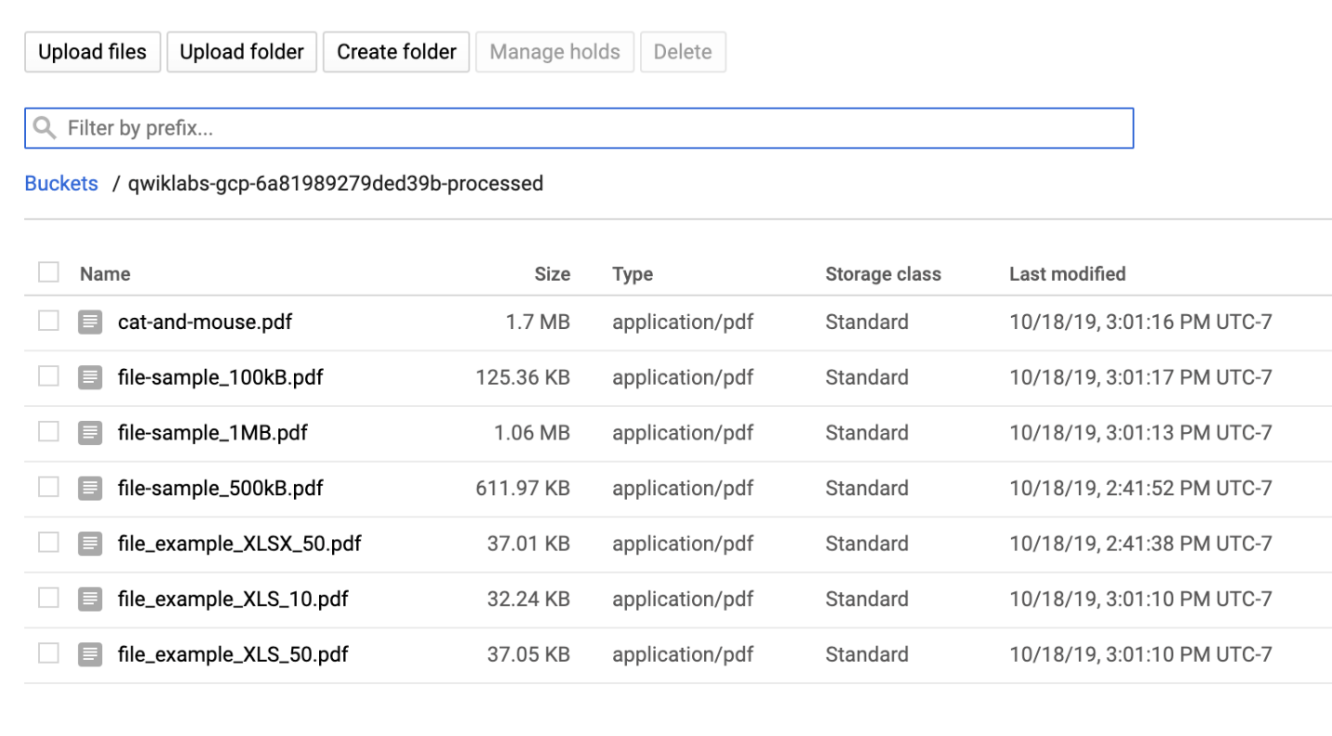

# Build a Resilient, Asynchronous System with Cloud Run and Pub/Sub

1 hourFree

## GSP650





## Overview

For the labs in the GCP Serverless Workshop: Pet Theory Quest, you will read through a fictitious business scenario and assist the characters with their serverless migration plan.

Twelve years ago, Lily started the Pet Theory chain of veterinary clinics. Over the years, the number of clinics has grown, and so has the need for automation. The way Pet Theory handles the results of medical tests when they come back from the lab is too slow and error-prone, and Lily wants to improve this.

Currently, Patrick, Pet Theory's IT administrator, handles test results manually. Whenever a test result comes back, he composes and sends an email to the client whose pet was tested, then he taps out a text message on his phone and sends the results as a text to the client.

Patrick is working with Ruby, a software consultant, to design a more scalable system. They want to build a solution that doesn't require a lot of ongoing maintenance. Patrick and Ruby have decided to go with serverless technology.

### **Prerequisites**

This lab assumes familiarity with the GCP Console and shell environments. This lab is part of a series. Taking the previous labs could be helpful, but is not necessary:

* [Migrating Data to a Firestore Database](https://google.qwiklabs.com/catalog_lab/2163)
* [Build a Serverless Web App with Firebase and Firestore](https://google.qwiklabs.com/catalog_lab/2166)
* [Build a Serverless App that Creates PDF Files with Cloud Run](https://google.qwiklabs.com/catalog_lab/2161)
* [Share Data Securely via a REST API](https://google.qwiklabs.com/catalog_lab/2167)

You should also be comfortable editing files. You can use your favorite text editor (like nano, vi, etc.) or you can launch the code editor from Cloud Shell, which can be found in the top ribbon:



## Setup and Requirements

#### Before you click the Start Lab button

Read these instructions. Labs are timed and you cannot pause them. The timer, which starts when you click **Start Lab**, shows how long Google Cloud resources will be made available to you.

This Qwiklabs hands-on lab lets you do the lab activities yourself in a real cloud environment, not in a simulation or demo environment. It does so by giving you new, temporary credentials that you use to sign in and access Google Cloud for the duration of the lab.

#### What you need

To complete this lab, you need:

* Access to a standard internet browser (Chrome browser recommended).
* Time to complete the lab.

**Note:** If you already have your own personal Google Cloud account or project, do not use it for this lab.

**Note:** If you are using a Pixelbook, open an Incognito window to run this lab.

#### How to start your lab and sign in to the Google Cloud Console

1. Click the **Start Lab** button. If you need to pay for the lab, a pop-up opens for you to select your payment method. On the left is a panel populated with the temporary credentials that you must use for this lab.



1. Copy the username, and then click **Open Google Console**. The lab spins up resources, and then opens another tab that shows the **Sign in** page.



**Tip:** Open the tabs in separate windows, side-by-side.

If you see the **Choose an account** page, click **Use Another Account**. 

1. In the **Sign in** page, paste the username that you copied from the Connection Details panel. Then copy and paste the password.

**Important:** You must use the credentials from the Connection Details panel. Do not use your Qwiklabs credentials. If you have your own Google Cloud account, do not use it for this lab (avoids incurring charges).

1. Click through the subsequent pages:
   * Accept the terms and conditions.
   * Do not add recovery options or two-factor authentication (because this is a temporary account).
   * Do not sign up for free trials.

After a few moments, the Cloud Console opens in this tab.

**Note:** You can view the menu with a list of Google Cloud Products and Services by clicking the **Navigation menu** at the top-left. 

### **Activate Cloud Shell**

Cloud Shell is a virtual machine that is loaded with development tools. It offers a persistent 5GB home directory and runs on the Google Cloud. Cloud Shell provides command-line access to your Google Cloud resources.

In the Cloud Console, in the top right toolbar, click the **Activate Cloud Shell** button.



Click **Continue**.



It takes a few moments to provision and connect to the environment. When you are connected, you are already authenticated, and the project is set to your PROJECT_ID. For example:



gcloud is the command-line tool for Google Cloud. It comes pre-installed on Cloud Shell and supports tab-completion.

You can list the active account name with this command:

gcloud auth list

content_copy

(Output)

Credentialed accounts:

- <myaccount>@<mydomain>.com (active)content_copy

(Example output)

Credentialed accounts:

- google1623327_student@qwiklabs.netcontent_copy

You can list the project ID with this command:

gcloud config list project

content_copy

(Output)

[core]

project = <project_ID>content_copy

(Example output)

[core]

project = qwiklabs-gcp-44776a13dea667a6content_copy

For full documentation of gcloud see the [gcloud command-line tool overview](https://cloud.google.com/sdk/gcloud).

Pet Theory would like to automate the process of sharing client test results. They have experienced a tough time keeping up with an increased volume of appointments, so Lily decides to ask Ruby for some assistance...

|  |  |
| --- | --- |
| image  Lily, Founder of Pet Theory | Hi Ruby,  Thanks for sorting out the insurance portal.  I was wondering if something could be done about the medical test results? We need a more efficient way of sending results to our clients.  Lily |
| image  Ruby, Software Consultant | Hey Lily,  Sure - let me see what I can do. I have a few ideas that may improve the situation.  Ruby |

## Architecture

Pet Theory uses an external company for medical tests. Once the lab company completes a medical test, they send the results back to Pet Theory.

The lab company use a HTTP(s) POST to Pet Theory's web endpoint for medical lab results. The illustration below outlines the general architecture.

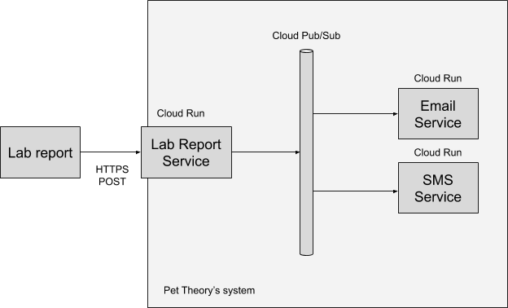

After looking at the general process followed, Ruby believes that a system can be designed in which Pet Theory is able to:

1. Receive the HTTP POST request and confirm receipt to the medical lab.
2. Email the test result to the client.
3. Send a text message (SMS) and an email to the client with the test result.

Ruby's design isolates each of the above activities and requires:

* A service to perform the request and response for the medical result(s)
* A service to email test results to the client
* A service to send a text message (SMS) to the client
* Pub/Sub to be used for inter-service communication
* Serverless infrastructure to be used for the application architecture

Through the use of single use functions, Ruby is looking to develop code that is easier to write and contains fewer bugs.

|  |  |
| --- | --- |
| image  Ruby, Software Consultant | Hi Patrick,  Lily would like me to build a prototype to help with the processing of medical records.  To get started, could you set up a Pub/Sub Topic called new-lab-report.  Ruby |
| image  Patrick, IT Administrator | Hey Ruby,  That sounds like a cool project. I can get that finished for you this morning, both activities are really quick to setup on GCP.  Patrick |

### **Create a Pub/Sub topic**

Help Patrick to create a Pub/Sub topic called new-lab-report.

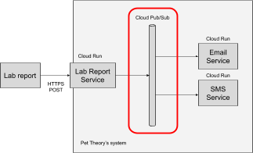

When a service publishes a Pub/Sub message, that message must be tagged with a topic. The Lab Report is consumed via the service to be created and publish a message for each report found.

First you need to create a topic that can be used for this task.

Run the following command to create a Pub/Sub topic:

gcloud pubsub topics create new-lab-report

content_copy

Any service subscribed to the topic "new-lab-report" will be able to consume the message published by the Lab Report Service. In the above diagram you can see two such consumers, Email Service and SMS Service.

Then enable Cloud Run, which will run your code in the cloud:

gcloud services enable run.googleapis.com

content_copy

Click **Check my progress** to verify the objective.

Create a Pub/Sub topic

Check my progress

Don't forget to update Ruby to let her know that the Pub/Sub topic is ready for her!

|  |  |
| --- | --- |
| image  Patrick, IT Administrator | Hey Ruby,  All done.  If you have time, I would like to see how this prototype is put together. Could we work on this together?  Patrick |
| image  Ruby, Software Consultant | Hi Patrick,  That's great, thanks for getting to this so quickly. I'll set up a time and we'll start building.  Ruby |

## Build the Lab Report Service

Help Ruby to set up the new Lab Report Service.

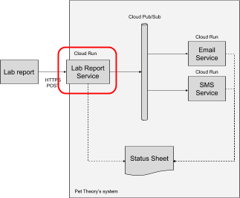

This service will serve the purpose of prototyping, so it will only do two things:

1. Receive the lab report HTTPS POST containing the report data.
2. Publish a message on Pub/Sub.

### **Add code for the Lab Report Service**

Back in Cloud Shell, clone the repository needed for this lab:

git clone https://github.com/rosera/pet-theory.git

content_copy

Move to the lab-service directory:

cd pet-theory/lab05/lab-service

content_copy

Install the following packages that will be needed to receive incoming HTTPS requests and publish to Pub/Sub:

npm install express

npm install body-parser

npm install @google-cloud/pubsub

content_copy

These commands update the file package.json to indicate the dependencies required for this service.

You will now edit the package.json file so that Cloud Run knows how to start your code.

Open the package.json file.

In the "scripts" section, add the "start": "node index.js" line as shown below and then save the file.

"scripts": {

"start": "node index.js",

"test": "echo \"Error: no test specified\" && exit 1"

},

content_copy

Create a new file named index.js and add this code to it:

const {PubSub} = require('@google-cloud/pubsub');

const pubsub = new PubSub();

const express = require('express');

const app = express();

const bodyParser = require('body-parser');

app.use(bodyParser.json());

const port = process.env.PORT || 8080;

app.listen(port, () => {

console.log('Listening on port', port);

});

app.post('/', async (req, res) => {

try {

const labReport = req.body;

await publishPubSubMessage(labReport);

res.status(204).send();

}

catch (ex) {

console.log(ex);

res.status(500).send(ex);

}

})

async function publishPubSubMessage(labReport) {

const buffer = Buffer.from(JSON.stringify(labReport));

await pubsub.topic('new-lab-report').publish(buffer);

}

content_copy

The heart of the code is this section:

const labReport = req.body;

await publishPubSubMessage(labReport);

content_copy

These two lines do the main work of the service:

1. Extract the lab report from the POST request.
2. Publish a PubSub message containing the newly posted lab report.

Now create a file named Dockerfile and add the code below into it:

FROM node:10

WORKDIR /usr/src/app

COPY package.json package*.json ./

RUN npm install --only=production

COPY . .

CMD [ "npm", "start" ]

content_copy

This file defines how to package up the Cloud Run service into a container.

### **Deploy the lab-report-service**

Create a script named deploy.sh and paste these commands into it:

gcloud builds submit \

--tag gcr.io/$GOOGLE_CLOUD_PROJECT/lab-report-service

gcloud run deploy lab-report-service \

--image gcr.io/$GOOGLE_CLOUD_PROJECT/lab-report-service \

--platform managed \

--region us-central1 \

--allow-unauthenticated

content_copy

Run the following to make this file executable:

chmod u+x deploy.sh

content_copy

It's time to deploy the Lab Report Service! Run the deployment script:

./deploy.sh

content_copy

Due to timing issues, you may get an error the first time you run this command. If you do, simply rerun deploy.sh.

When the deployment has successfully completed, you will see a message similar to this:

Service [lab-report-service] revision [lab-report-service-00001] has been deployed and is serving traffic at https://lab-report-service-[hash].a.run.app

content_copy

Nice work, the Lab Report Service has been deployed and will consume medical lab results over HTTP. You can now test if the new service is up and running.

Click **Check my progress** to verify the objective.

Deploy the Lab Report Service: Build

Check my progress

Click **Check my progress** to verify the objective.

Deploy the Lab Report Service: Create Revision

Check my progress

### **Test the Lab Report Service**

To validate the Lab Report Service, simulate three HTTPS POSTs made by the lab company, each containing one lab report. For the purpose of testing, the lab reports created will only contain an ID.

First, put the URL to the report in an environment variable, to make it easier to work with.

export LAB_REPORT_SERVICE_URL=$(gcloud run services describe lab-report-service --platform managed --region us-central1 --format="value(status.address.url)")

content_copy

Confirm the LAB_REPORT_SERVICE_URL has been captured:

echo $LAB_REPORT_SERVICE_URL

content_copy

Create a new file named post-reports.sh and add the code below into it:

curl -X POST \

-H "Content-Type: application/json" \

-d "{\"id\": 12}" \

$LAB_REPORT_SERVICE_URL &

curl -X POST \

-H "Content-Type: application/json" \

-d "{\"id\": 34}" \

$LAB_REPORT_SERVICE_URL &

curl -X POST \

-H "Content-Type: application/json" \

-d "{\"id\": 56}" \

$LAB_REPORT_SERVICE_URL &

content_copy

The above script will use the curl command to post three distinct ID's to the Lab Service URL. Each command will be run individually in the background.

Make the post-reports.sh script executable:

chmod u+x post-reports.sh

content_copy

Now test the Lab Report Service endpoint by posting three lab reports to it using the script outlined above:

./post-reports.sh

content_copy

This script posted three lab reports to your Lab Report Service. Check the logs to see the results!

From the **Navigation menu** click **Cloud Run**.

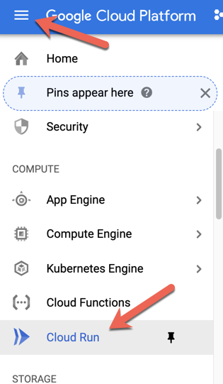

You should now see your newly deployed **lab-report-service**. Click it.

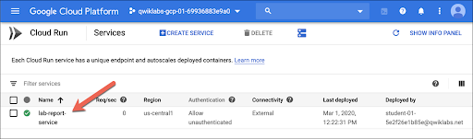

The next page shows details about your lab-report-service. Click the **Logs** tab.

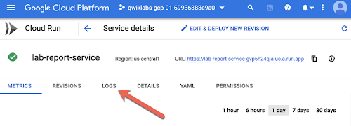

On the Logs page are the results of the three test reports that you just posted with the script. Hopefully the returned HTTP codes are 204, meaning OK - not content, shown below. If you don’t see any entries, try scrolling up and down using the scrollbar to the right. This reloads the log.

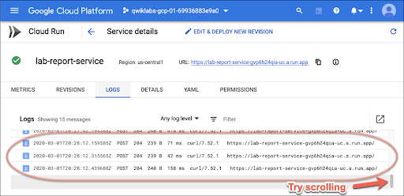

The next task is to write the SMS and Email services. These services will be triggered when the Lab Report Service publishes a Pub/Sub message on the "new-lab-report" topic.

## The Email Service

Help Ruby to set up the new Email Service.

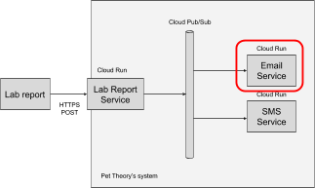

### **Add code for the Email Service**

Move to the Email Service directory:

cd ~/pet-theory/lab05/email-service

content_copy

Install these packages so that the code can handle incoming HTTPS requests.

npm install express

npm install body-parser

content_copy

The above command will update the package.json file, which describes the app and its dependencies. Cloud Run needs to know how to run the code, so add start instruction so that it knows what to do.

Open the package.json file.

In the "scripts" section, add the "start": "node index.js" line as shown below and save the file.

"scripts": {

"start": "node index.js",

"test": "echo \"Error: no test specified\" && exit 1"

},

content_copy

Create a new file called index.js and add the following to it:

const express = require('express');

const app = express();

const bodyParser = require('body-parser');

app.use(bodyParser.json());

const port = process.env.PORT || 8080;

app.listen(port, () => {

console.log('Listening on port', port);

});

app.post('/', async (req, res) => {

const labReport = decodeBase64Json(req.body.message.data);

try {

console.log(`Email Service: Report ${labReport.id} trying...`);

sendEmail();

console.log(`Email Service: Report ${labReport.id} success :-)`);

res.status(204).send();

}

catch (ex) {

console.log(`Email Service: Report ${labReport.id} failure: ${ex}`);

res.status(500).send();

}

})

function decodeBase64Json(data) {

return JSON.parse(Buffer.from(data, 'base64').toString());

}

function sendEmail() {

console.log('Sending email');

}

content_copy

This code will run when Pub/Sub posts a message to the service. This is what it does:

* It decodes the Pub/Sub message and then tries to call the sendEmail() function.
* If that succeeds and no exception is thrown, it will return status code 204 so Pub/Sub knows that the message was processed.
* If there is an exception, the service will return status code 500 so that Pub/Sub knows the message was not processed and it should re-post it to the service later.

Once the communication between services is working, Ruby will add code to the sendEmail() function to actually send the email.

Now create a file named Dockerfile and add the code below into it:

FROM node:10

WORKDIR /usr/src/app

COPY package.json package*.json ./

RUN npm install --only=production

COPY . .

CMD [ "npm", "start" ]

content_copy

This file defines how to package up the Cloud Run service into a container.

### **Deploy the Email Service**

Create a new file called deploy.sh and add the following to it:

gcloud builds submit \

--tag gcr.io/$GOOGLE_CLOUD_PROJECT/email-service

gcloud run deploy email-service \

--image gcr.io/$GOOGLE_CLOUD_PROJECT/email-service \

--platform managed \

--region us-central1 \

--no-allow-unauthenticated

content_copy

Make deploy.sh executable:

chmod u+x deploy.sh

content_copy

Deploy the Email Service:

./deploy.sh

content_copy

When the deployment is complete, you will see a message similar to this:

Service [email-service] revision [email-service-00001] has been deployed and is serving traffic at https://email-service-[hash].a.run.app

content_copy

The service has been successfully deployed. You now need to ensure the Email Service is triggered when a Pub/Sub message is available.

Click **Check my progress** to verify the objective.

Deploy the Email Service: Build

Check my progress

Click **Check my progress** to verify the objective.

Deploy the Email Service: Create Revision

Check my progress

### **Configure Pub/Sub to trigger the Email Service**

Whenever a new Pub/Sub message is published using the "new-lab-report" topic, it should trigger the Email Service. To achieve this task, configure a service account to automatically handle the associated requests for this service.

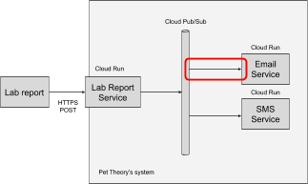

Create a new service account that will be used to trigger the services responding to Pub/Sub messages:

gcloud iam service-accounts create pubsub-cloud-run-invoker --display-name "PubSub Cloud Run Invoker"

content_copy

Click **Check my progress** to verify the objective.

Create a service account

Check my progress

Give the new service account permission to invoke the Email Service:

gcloud run services add-iam-policy-binding email-service --member=serviceAccount:pubsub-cloud-run-invoker@$GOOGLE_CLOUD_PROJECT.iam.gserviceaccount.com --role=roles/run.invoker --region us-central1 --platform managed

content_copy

Next, tell Pub/Sub to invoke the SMS Service when a "new-lab-report" message is published.

Put the project number in an environment variable for easy access:

PROJECT_NUMBER=$(gcloud projects list --filter="qwiklabs-gcp" --format='value(PROJECT_NUMBER)')

content_copy

Next, enable the project to create Pub/Sub authentication tokens.

Run the code below:

gcloud projects add-iam-policy-binding $GOOGLE_CLOUD_PROJECT --member=serviceAccount:service-$PROJECT_NUMBER@gcp-sa-pubsub.iam.gserviceaccount.com --role=roles/iam.serviceAccountTokenCreator

content_copy

Put the URL of the Email Service in another environment variable:

EMAIL_SERVICE_URL=$(gcloud run services describe email-service --platform managed --region us-central1 --format="value(status.address.url)")

content_copy

Confirm the EMAIL_SERVICE_URL has been captured:

echo $EMAIL_SERVICE_URL

content_copy

Create a Pub/Sub subscription for the Email Service.

gcloud pubsub subscriptions create email-service-sub --topic new-lab-report --push-endpoint=$EMAIL_SERVICE_URL --push-auth-service-account=pubsub-cloud-run-invoker@$GOOGLE_CLOUD_PROJECT.iam.gserviceaccount.com

content_copy

Nice work, the service is now set up to respond to Cloud Pub/Sub messages, as a next step validate the code to confirm it meets requirements.

Click **Check my progress** to verify the objective.

Create the Pub/Sub subscription

Check my progress

### **Test the Lab Report Service and the Email Service together**

Using the script created earlier, post to the lab reports again:

~/pet-theory/lab05/lab-service/post-reports.sh

content_copy

Then open the log (**Navigation menu** > **Cloud Run**). You will see the two Cloud Run services in your account.

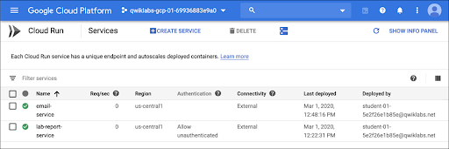

Click **email-service** and then click **Logs**. You will see the result of this service being triggered by Pub/Sub. If you don’t see the messages you expect, you may need to scroll up and down with the scrollbar to get the log to refresh.

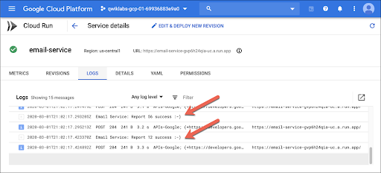

Great job! The Email service is now able to write information to the log whenever a message is processed from the Cloud Pub/Sub topic queue! The last task is to write the SMS Service.

## The SMS Service

Help Ruby to set up the new SMS Service.

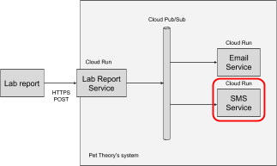

### **Add code for the SMS Service**

Create a directory for the SMS Service:

cd ~/pet-theory/lab05/sms-service

content_copy

Install the packages required to receive incoming HTTPS requests:

npm install express

npm install body-parser

content_copy

Open the package.json file.

In the "scripts" section, add the "start": "node index.js" line as shown below and save the file.

...

"scripts": {

"start": "node index.js",

"test": "echo \"Error: no test specified\" && exit 1"

},

...

content_copy

Create a new file called index.js and add the following to it:

const express = require('express');

const app = express();

const bodyParser = require('body-parser');

app.use(bodyParser.json());

const port = process.env.PORT || 8080;

app.listen(port, () => {

console.log('Listening on port', port);

});

app.post('/', async (req, res) => {

const labReport = decodeBase64Json(req.body.message.data);

try {

console.log(`SMS Service: Report ${labReport.id} trying...`);

sendSms();

console.log(`SMS Service: Report ${labReport.id} success :-)`);

res.status(204).send();

}

catch (ex) {

console.log(`SMS Service: Report ${labReport.id} failure: ${ex}`);

res.status(500).send();

}

})

function decodeBase64Json(data) {

return JSON.parse(Buffer.from(data, 'base64').toString());

}

function sendSms() {

console.log('Sending SMS');

}

content_copy

Now create a file named Dockerfile and add the code below into it:

FROM node:10

WORKDIR /usr/src/app

COPY package.json package*.json ./

RUN npm install --only=production

COPY . .

CMD [ "npm", "start" ]

content_copy

This file defines how to package up the Cloud Run service into a container. Now the code has been created, the next step is to deploy the service.

### **Deploy the SMS Service**

Create a file named deploy.sh and add this code into it:

gcloud builds submit \

--tag gcr.io/$GOOGLE_CLOUD_PROJECT/sms-service

gcloud run deploy sms-service \

--image gcr.io/$GOOGLE_CLOUD_PROJECT/sms-service \

--platform managed \

--region us-central1 \

--no-allow-unauthenticated

content_copy

Make deploy.sh executable:

chmod u+x deploy.sh

content_copy

Deploy the SMS Service:

./deploy.sh

content_copy

When the deployment is complete, a message similar to this is displayed:

Service [sms-service] revision [sms-service-00001] has been deployed and is serving traffic at https://sms-service-[hash].a.run.app

content_copy

The SMS Service is successfully deployed, but it isn't linked to the Cloud Pub/Sub service. Correct that in the next section.

Click **Check my progress** to verify the objective.

Deploy the SMS Service

Check my progress

### **Configure Cloud Pub/Sub to trigger the SMS Service**

As with the Email Service, the link between Cloud Pub/Sub and the SMS service needs to be configured so that messages can be consumed.

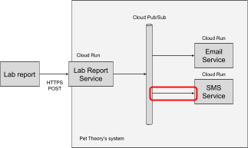

Set the permissions to allow Pub/Sub to trigger the SMS Service:

gcloud run services add-iam-policy-binding sms-service --member=serviceAccount:pubsub-cloud-run-invoker@$GOOGLE_CLOUD_PROJECT.iam.gserviceaccount.com --role=roles/run.invoker --region us-central1 --platform managed

content_copy

Next, tell Pub/Sub to invoke the SMS Service when a “new-lab-report” message is published.

The first step is to put the URL address of the SMS Service in an environment variable:

SMS_SERVICE_URL=$(gcloud run services describe sms-service --platform managed --region us-central1 --format="value(status.address.url)")

content_copy

Confirm the SMS_SERVICE_URL has been captured:

echo $SMS_SERVICE_URL

content_copy

Then create the Pub/Sub subscription:

gcloud pubsub subscriptions create sms-service-sub --topic new-lab-report --push-endpoint=$SMS_SERVICE_URL --push-auth-service-account=pubsub-cloud-run-invoker@$GOOGLE_CLOUD_PROJECT.iam.gserviceaccount.com

content_copy

Run the test script again to post three lab reports to the Lab Report Service:

~/pet-theory/lab05/lab-service/post-reports.sh

content_copy

Then open the log (**Navigation menu** > **Cloud Run**). You will see the three Cloud Run services in your account.

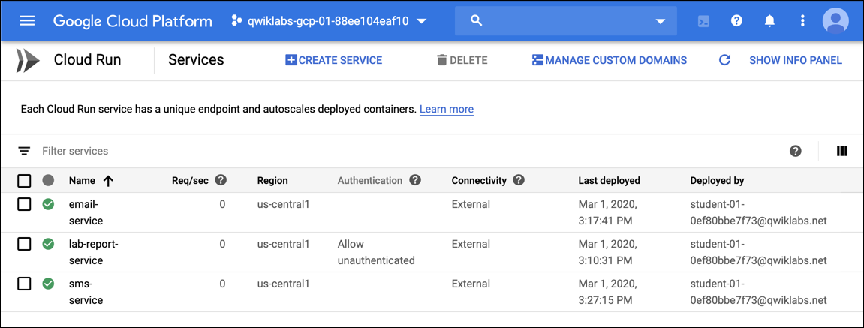

Click **sms-service**, then click **Logs**. You will see the result of this service being triggered by Pub/Sub.

The prototype system has been created and successfully tested. However, Patrick is concerned that resilience, as part of the initial validation process, hasn't been tested.

## Test the resiliency of the system

What happens if one of the services goes down? Patrick has run into this before, as it is a common situation.

Help Ruby investigate how to ensure the system can handle this scenario. She wants to test what happens when a service fails by deploying a bad version of the Email Service.

Go back to the email-service directory:

cd ~/pet-theory/lab05/email-service

content_copy

Add some invalid text to the Email Service application to cause an error.

Edit index.js and add the throw line to the sendEmail() function, as shown below. This will throw an exception, as if the email server was down:

...

function sendEmail() {

throw 'Email server is down';

console.log('Sending email');

}

...

content_copy

The addition of this code will crash the service when it is invoked.

Deploy this bad version of the Email Service:

./deploy.sh

content_copy

When the Email Service deployment has successfully completed, post data to the lab reports again, then go and watch the **email-service** log status closely:

~/pet-theory/lab05/lab-service/post-reports.sh

content_copy

Open the log for the bad Email Service: **Navigation menu** > **Cloud Run**. When you see the three Cloud Run services in your account, click **email-service**.

The Email Service is being invoked, but it will keep crashing. If you scroll back a bit in the logs you will find the root cause: “Email server is down”. You can also see that the service returns status code 500, and that Pub/Sub keeps retrying calling the service.

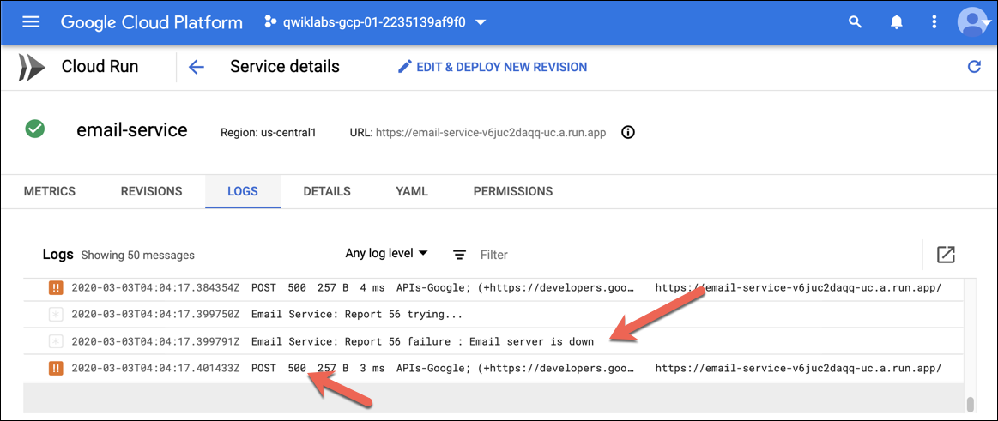

If you look at the logs from the SMS service, you will see that it operates successfully.

Now fix the error in the Email Service to restore the application!

Open the index.js file and remove the throw line you previously entered, then save the file.

Your index.js sendEmail function show now look similar to this:

function sendEmail() {

console.log('Sending email');

}

content_copy

Deploy the fixed version of the Email Service:

./deploy.sh

content_copy

When the deployment has finished, click the **refresh** icon in the top right corner.

You will see how the emails for report 12, 34 and 56 were finally sent, the Email Service returned the status code 204, and Pub/Sub stopped invoking the service. No data was lost; Pub/Sub kept retrying until it was finally successful. This is the foundation of a robust system!

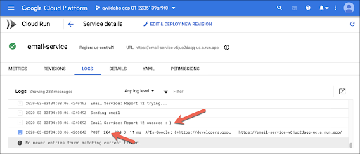

### **Takeaways**

1. If services communicate asynchronously with each other via Pub/Sub instead of calling each other directly, the system can be more resilient.
2. The Lab Report Service trigger is independent of other services, thanks to the use of Pub/Sub. For example, if customers should also want to receive lab results via another messaging service, it can be added without needing to update the Lab Report Service.
3. Cloud Pub/Sub handled the retries, the services didn't have to. Services are only required to return a status code: success or failure.
4. If a service goes down, the system is capable of automatically "healing" itself when the service comes back online, thanks to Pub/Sub retries.

# Developing a REST API with Go and Cloud Run

1 hourFree

## GSP761





## Overview

In this lab you will read through the scenario, then take the steps the characters take to solve the business problem.

Twelve years ago, Lily started the Pet Theory chain of veterinary clinics. As the chain of clinics has grown, Lily spends more time on the phone with insurance companies than treating pets. If only the insurance companies could see the totals of the treatments online!

In previous labs in this series, Ruby, the computer consultant, and Patrick, the DevOps Engineer, moved Pet Theory's customer database to a serverless Firestore database in the cloud, and then opened up access so customers can make appointments online. Since Pet Theory's Ops team is a single person, they need a serverless solution that doesn't require a lot of ongoing maintenance.

In this lab, you'll help Ruby and Patrick to give insurance companies access to customer data without exposing Personal Identifiable Information (PII). You will build a secure Representational State Transfer (REST) API gateway using Cloud Run, which is serverless. This will let the insurance companies see the total cost of treatments without seeing customers' PII.

## Prerequisites

This is a **fundamental level** lab. This assumes familiarity with the Cloud Console and Cloud Shell environments. This lab is part of a series. Taking the previous labs could be helpful, but is not necessary:

* Importing Data to a Serverless Database
* Build a Serverless Web App with Firebase and Firestore
* Build a Serverless App that Creates PDF Files

You should also be comfortable editing files. You can use your favorite text editor (like nano, vi, etc.) or you can launch the code editor from Cloud Shell, which can be found from the top ribbon:



## Setup

#### Before you click the Start Lab button

Read these instructions. Labs are timed and you cannot pause them. The timer, which starts when you click **Start Lab**, shows how long Google Cloud resources will be made available to you.

This Qwiklabs hands-on lab lets you do the lab activities yourself in a real cloud environment, not in a simulation or demo environment. It does so by giving you new, temporary credentials that you use to sign in and access Google Cloud for the duration of the lab.

#### What you need

To complete this lab, you need:

* Access to a standard internet browser (Chrome browser recommended).
* Time to complete the lab.

**Note:** If you already have your own personal Google Cloud account or project, do not use it for this lab.

**Note:** If you are using a Pixelbook, open an Incognito window to run this lab.

#### How to start your lab and sign in to the Google Cloud Console

1. Click the **Start Lab** button. If you need to pay for the lab, a pop-up opens for you to select your payment method. On the left is a panel populated with the temporary credentials that you must use for this lab.



1. Copy the username, and then click **Open Google Console**. The lab spins up resources, and then opens another tab that shows the **Sign in** page.



**Tip:** Open the tabs in separate windows, side-by-side.

If you see the **Choose an account** page, click **Use Another Account**. 

1. In the **Sign in** page, paste the username that you copied from the Connection Details panel. Then copy and paste the password.

**Important:** You must use the credentials from the Connection Details panel. Do not use your Qwiklabs credentials. If you have your own Google Cloud account, do not use it for this lab (avoids incurring charges).

1. Click through the subsequent pages:
   * Accept the terms and conditions.
   * Do not add recovery options or two-factor authentication (because this is a temporary account).
   * Do not sign up for free trials.

After a few moments, the Cloud Console opens in this tab.

**Note:** You can view the menu with a list of Google Cloud Products and Services by clicking the **Navigation menu** at the top-left. 

### **Activate Cloud Shell**

Cloud Shell is a virtual machine that is loaded with development tools. It offers a persistent 5GB home directory and runs on the Google Cloud. Cloud Shell provides command-line access to your Google Cloud resources.

In the Cloud Console, in the top right toolbar, click the **Activate Cloud Shell** button.



Click **Continue**.



It takes a few moments to provision and connect to the environment. When you are connected, you are already authenticated, and the project is set to your PROJECT_ID. For example:



gcloud is the command-line tool for Google Cloud. It comes pre-installed on Cloud Shell and supports tab-completion.

You can list the active account name with this command:

gcloud auth list

content_copy

(Output)

Credentialed accounts:

- <myaccount>@<mydomain>.com (active)content_copy

(Example output)

Credentialed accounts:

- google1623327_student@qwiklabs.netcontent_copy

You can list the project ID with this command:

gcloud config list project

content_copy

(Output)

[core]

project = <project_ID>content_copy

(Example output)

[core]

project = qwiklabs-gcp-44776a13dea667a6content_copy

For full documentation of gcloud see the [gcloud command-line tool overview](https://cloud.google.com/sdk/gcloud).

|  |  |
| --- | --- |
| image  Lily, Founder of Pet Theory | Hi Ruby,  Remember our conversation last week when I expressed how swamped I am with with paperwork and phone calls from the insurance company? If only there was a way to allow the representatives to access customer records in an efficient, secure way.  This current level of workload isn't sustainable. Can you help?  Lily |
| image  Ruby, Software Consultant | Hi Lily,  Yesterday I had lunch with Patrick and we drew up a plan to make it easier for authorized 3rd parties to securely access Pet Theory's digital records.  We will build this in four steps:   1. Build a simple REST API. 2. Import customer test data. 3. Connect the REST API to the customer database. 4. Add authentication to the REST API.   Patrick and I already have the skillset for steps 1 + 2, so we are off to a good start. We plan to have a working prototype by the end of the week.  Ruby |

Help Ruby manage the activities necessary to build the REST API for Pet Theory.

## Enable Google APIs

For this lab 2 APIs are enabled have been enabled for you:

|  |  |
| --- | --- |
| **Name** | **API** |
| Cloud Build | cloudbuild.googleapis.com |
| Cloud Run | run.googleapis.com |

## Developing the REST API

1. Activate the your project:

gcloud config set project $(gcloud projects list --format='value(PROJECT_ID)' --filter='qwiklabs-gcp')

content_copy

1. Create a new directory for the application:

mkdir gsp761 && cd $_

content_copy

1. Use your favorite text editor, or use the Code Editor button in the Cloud Shell ribbon, to create the file go.mod, then add this content to the file:

module github.com/ymotongpoo/pet-theory

go 1.13

content_copy

1. Create the file main.go and add the below contents to the file:

package main

import (

"fmt"

"log"

"net/http"

"os"

)

func main() {

port := os.Getenv("PORT")

if port == "" {

port = "8080"

}

http.HandleFunc("/v1/", func(w http.ResponseWriter, r *http.Request) {

fmt.Fprintf(w, "{status: 'running'}")

})

log.Println("Pets REST API listening on port", port)

if err := http.ListenAndServe(":"+port, nil); err != nil {

log.Fatalf("Error launching Pets REST API server: %v", err)

}

}

content_copy

In the above code, you create an endpoint to test that the service is up and running as expected. By appending "/v1/" to the service URL, you can verify the application is functioning as expected. Cloud Run deploys containers, so you need to provide a container definition. A file named `Dockerfile` tells Cloud Run which Go version to use, which files to include in the app, and how to start the code.

1. Now create a file named Dockerfile and add the following to it:

FROM gcr.io/distroless/base-debian10

WORKDIR /usr/src/app

COPY server .

CMD [ "/usr/src/app/server" ]

content_copy

The file server is the execution binary built from main.go.

1. Run the following command to build the binary:

go build -o server

content_copy

1. After running the build command, make sure that you have necessary Dockerfile and server in the same directory.

ls -la

content_copy

(Output)

.

├── Dockerfile

├── go.mod

├── main.go

└── server

content_copy

For most Cloud Run Go based apps, a template Dockerfile like the one above can typically be used without modifying it.

1. Deploy your simple REST API by running:

gcloud builds submit \

--tag gcr.io/$GOOGLE_CLOUD_PROJECT/rest-api:0.1

content_copy

This command builds a container with your code and puts it in the Container Registry of your project. You can see the container if you click: **Navigation menu** > **Container Registry**. If you don't see rest-api, click **Refresh**.

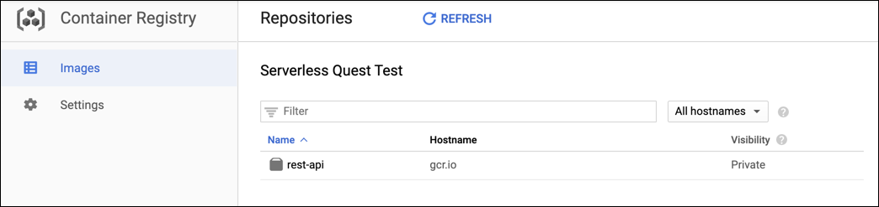

Click **Check my progress** to verify that you've performed the above task.

Build an image with Cloud Build

Check my progress

1. Once the container has been built, deploy it:

gcloud beta run deploy rest-api \

--image gcr.io/$GOOGLE_CLOUD_PROJECT/rest-api:0.1 \

--platform managed \

--region us-central1 \

--allow-unauthenticated

content_copy

1. When the deployment is complete, you will see a message like this:

Service [rest-api] revision [rest-api-00001] has been deployed and is serving

traffic at https://rest-api-[hash].a.run.app

content_copy

Click **Check my progress** to verify that you've performed the above task.

REST API service deployed

Check my progress

1. Click on the Service URL at the end of that message to open it in a new browser tab. Append /v1/ to the end of the URL and then press **Enter**. You should see this message:

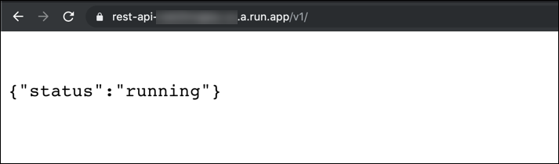

The REST API is up and running. With the prototype service available, in the next section the API will be used to retrieve "customer" information from a Firestore database.

## Import test customer data

|  |  |
| --- | --- |
| image  Ruby, Software Consultant | Hey Patrick,  Do you still have the pseudo customer data we created a while back? We will need that for testing.  Do you remember how to set up a Firestore database and import data?  Ruby |
| image  Patrick, IT Administrator | Hi Ruby,  Yes, I still have the test data. I will migrate it to Firestore today so you can use it for testing.  Patrick |

Ruby and Patrick have previously created a test database of 10 customers, with some proposed treatments for one customer's cat.

Help Patrick configure the Firestore database and import the customer test data. First, enable Firestore in your project.

1. Return to the Cloud Console and click the **Navigation Menu** > **Firestore**.

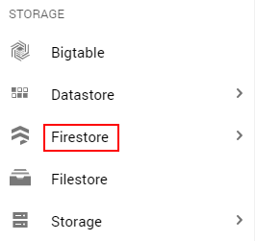

1. Click the **Select Native Mode** button.

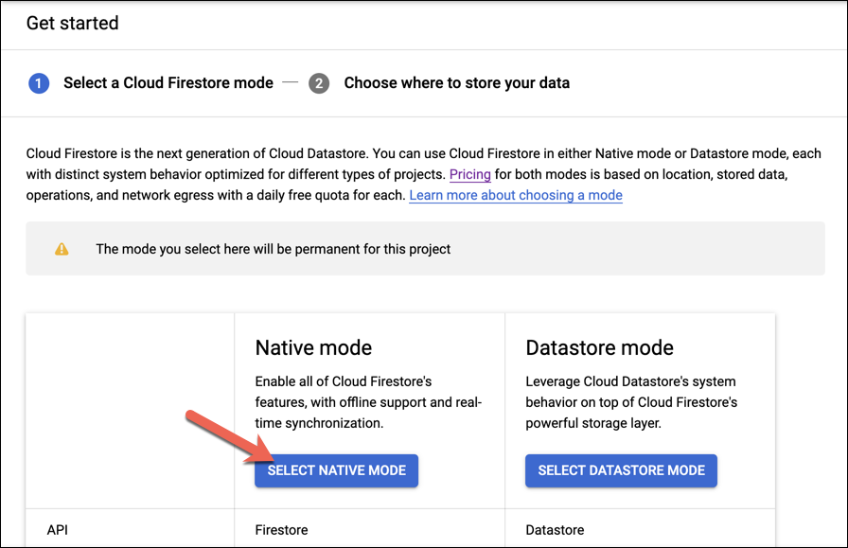

1. Select the location "nam5" (United States) multi-region near the top of the list.
2. Click the **Create Database** button.
3. Wait for the database to be created.

Click **Check my progress** to verify that you've performed the above task.

Firestore database created

Check my progress

1. Migrate the import files into a Cloud Storage bucket that has been created for you:

gsutil cp -r gs://spls/gsp645/2019-10-06T20:10:37_43617 gs://$GOOGLE_CLOUD_PROJECT-customer

content_copy

1. Now import this data into Firebase:

gcloud beta firestore import gs://$GOOGLE_CLOUD_PROJECT-customer/2019-10-06T20:10:37_43617/

content_copy

Reload the Cloud Console browser to see the Firestore results.

1. In Firestore, click **customers** under "Root". You should see the imported pet data, like the screenshot below. Feel free to browse around. If you don't see any data, try refreshing the page.



Nice work, the Firestore database has been successfully created and populated with test data!

## Connect the REST API to the Firestore database

|  |  |
| --- | --- |
| image  Ruby, Software Consultant | Hi Lily,  Just a quick update: Patrick and I have completed the first two tasks on the list.  Now I'm moving on to structuring the REST API so it can access the customer data in Firestore.  Ruby |
| image  Lily, Founder of Pet Theory | Hi Ruby,  Great work, Ruby! Looking forward to seeing the next stage in action.  Lily |

In this section you'll help Ruby create another end-point in the REST API that will look like this:

https://rest-api-[hash].a.run.app/v1/customer/22530

content_copy

For example, that URL should return the total amounts for all proposed, accepted, and rejected treatments for the customer with id 22530, if they exist in the Firestore database:

{

"status": "success",

"data": {

"proposed": 1602,

"approved": 585,

"rejected": 489

}

}

content_copy

If the customer doesn't exist in the database, status code 404 (not found) and an error message should be returned instead.

This new functionality requires a package to access the Firestore database and another one to handle cross-origin resource sharing (CORS).

1. Get the value of the $GOOGLE_CLOUD_PROJECT environment variable

echo $GOOGLE_CLOUD_PROJECT

content_copy

1. Open the existing main.go file in the pet-theory/gsp761 directory.

Update the contents of main.go using the value shown for $GOOGLE_CLOUD_PROJECT

3 Replace the *PROJECT_ID* in the code below:_

package main

import (

"context"

"encoding/json"

"fmt"

"log"

"net/http"

"os"

"cloud.google.com/go/firestore"

"github.com/gorilla/handlers"

"github.com/gorilla/mux"

"google.golang.org/api/iterator"

)

var client *firestore.Client

func main() {

var err error

ctx := context.Background()

client, err = firestore.NewClient(ctx, "PROJECT_ID")

if err != nil {

log.Fatalf("Error initializing Cloud Firestore client: %v", err)

}

port := os.Getenv("PORT")

if port == "" {

port = "8080"

}

r := mux.NewRouter()

r.HandleFunc("/v1/", rootHandler)

r.HandleFunc("/v1/customer/{id}", customerHandler)

log.Println("Pets REST API listening on port", port)

cors := handlers.CORS(

handlers.AllowedHeaders([]string{"X-Requested-With", "Authorization", "Origin"}),

handlers.AllowedOrigins([]string{"https://storage.googleapis.com"}),

handlers.AllowedMethods([]string{"GET", "HEAD", "POST", "OPTIONS", "PATCH", "CONNECT"}),

)

if err := http.ListenAndServe(":"+port, cors(r)); err != nil {

log.Fatalf("Error launching Pets REST API server: %v", err)

}

}

content_copy

1. Add handler support at the bottom of the file:

func rootHandler(w http.ResponseWriter, r *http.Request) {

fmt.Fprintf(w, "{status: 'running'}")

}

func customerHandler(w http.ResponseWriter, r *http.Request) {

id := mux.Vars(r)["id"]

ctx := context.Background()

customer, err := getCustomer(ctx, id)

if err != nil {

w.WriteHeader(http.StatusInternalServerError)

fmt.Fprintf(w, `{"status": "fail", "data": '%s'}`, err)

return

}

if customer == nil {

w.WriteHeader(http.StatusNotFound)

msg := fmt.Sprintf("`Customer \"%s\" not found`", id)

fmt.Fprintf(w, fmt.Sprintf(`{"status": "fail", "data": {"title": %s}}`, msg))

return

}

amount, err := getAmounts(ctx, customer)

if err != nil {

w.WriteHeader(http.StatusInternalServerError)

fmt.Fprintf(w, `{"status": "fail", "data": "Unable to fetch amounts: %s"}`, err)

return

}

data, err := json.Marshal(amount)

if err != nil {

w.WriteHeader(http.StatusInternalServerError)

fmt.Fprintf(w, `{"status": "fail", "data": "Unable to fetch amounts: %s"}`, err)

return

}

fmt.Fprintf(w, fmt.Sprintf(`{"status": "success", "data": %s}`, data))

}

content_copy

1. Add Customer support to the bottom of the file:

type Customer struct {

Email string `firestore:"email"`

ID string `firestore:"id"`

Name string `firestore:"name"`

Phone string `firestore:"phone"`

}

func getCustomer(ctx context.Context, id string) (*Customer, error) {

query := client.Collection("customers").Where("id", "==", id)

iter := query.Documents(ctx)

var c Customer

for {

doc, err := iter.Next()

if err == iterator.Done {

break

}

if err != nil {

return nil, err

}

err = doc.DataTo(&c)

if err != nil {

return nil, err

}

}

return &c, nil

}

func getAmounts(ctx context.Context, c *Customer) (map[string]int64, error) {

if c == nil {

return map[string]int64{}, fmt.Errorf("Customer should be non-nil: %v", c)

}

result := map[string]int64{

"proposed": 0,

"approved": 0,

"rejected": 0,

}

query := client.Collection(fmt.Sprintf("customers/%s/treatments", c.Email))

if query == nil {

return map[string]int64{}, fmt.Errorf("Query is nil: %v", c)

}

iter := query.Documents(ctx)

for {

doc, err := iter.Next()

if err == iterator.Done {

break

}

if err != nil {

return nil, err

}

treatment := doc.Data()

result[treatment["status"].(string)] += treatment["cost"].(int64)

}

return result, nil

}

content_copy

1. **Save** the file.

## Pop Quiz

Which function responds to URLs with the pattern `/v1/customer/`



getAmounts



customerHandler

Submit

Which statement returns success to the client



fmt.Fprintf(w, fmt.Sprintf(`{"status": "success", "data": %s}



fmt.Fprintf(w, `{"status": "fail", "data": "Unable to fetch amounts: %s"}

Submit

Which functions read from the Firestore database



getCustomer and getAmounts



customerHandler and getCustomer

Submit

## Deploying a new Revision

1. Rebuild the source code:

go build -o server

content_copy

1. Build a new image for the REST API:

gcloud builds submit \

--tag gcr.io/$GOOGLE_CLOUD_PROJECT/rest-api:0.2

content_copy

1. Deploy the updated image:

gcloud beta run deploy rest-api \

--image gcr.io/$GOOGLE_CLOUD_PROJECT/rest-api:0.2 \

--platform managed \

--region us-central1 \

--allow-unauthenticated

content_copy

Click **Check my progress** to verify that you've performed the above task.

Build image revision 0.2

Check my progress

1. When the deployment is complete, you will see a similar message to before. The URL for your REST API did not change when you deployed the new version:

Service [rest-api] revision [rest-api-00002] has been deployed and is serving

traffic at https://rest-api-[hash].a.run.app

content_copy

1. Go back to the browser tab that already points to that URL (with /v1 at the end). Refresh it and make sure you get the same message as before, that indicates that the API status is still running.

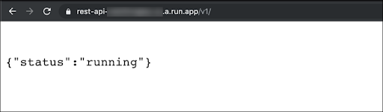

1. Append /customer/22530 to the application URL in your browser's address bar. You should get this JSON response, listing the sum total of the customer's proposed, approved and rejected treatments:

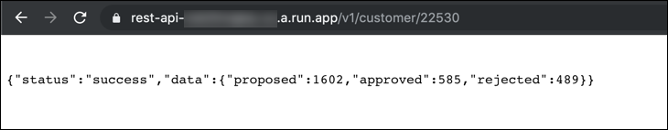

Here are some additional client IDs you can put in the URL instead of 22530:

* 34216
* 70156 (all amounts should be zero)
* 12345 (client/pet doesn't exist, should return an error e.g. **Query is nil**)

You have built a scalable, low-maintenance, serverless REST API that reads from a database.

# Creating PDFs with Go and Cloud Run

1 hourFree

## GSP762



## Overview

In this lab you will build a PDF converter web app on Cloud Run, which is a serverless service, that automatically converts files stored in Google Drive into PDFs stored in segregated Google Drive folders.

## Objectives

* Convert a Go application to a container
* Learn how to build containers with Google Cloud Build
* Create a Cloud Run service that converts files to PDF files in the cloud.
* Understand how to create Service Accounts and add permissions
* Use event processing with Google Cloud Storage

### **Prerequisites**

This is a **fundamental level** lab. This assumes familiarity with the Cloud Console and Cloud Shell.

You should also be comfortable editing files. You can use your favorite text editor (like nano, vi, etc.) or you can launch the code editor from Cloud Shell, which can be found from the top ribbon:



## Setup

#### Before you click the Start Lab button

Read these instructions. Labs are timed and you cannot pause them. The timer, which starts when you click **Start Lab**, shows how long Google Cloud resources will be made available to you.

This Qwiklabs hands-on lab lets you do the lab activities yourself in a real cloud environment, not in a simulation or demo environment. It does so by giving you new, temporary credentials that you use to sign in and access Google Cloud for the duration of the lab.

#### What you need

To complete this lab, you need:

* Access to a standard internet browser (Chrome browser recommended).
* Time to complete the lab.

**Note:** If you already have your own personal Google Cloud account or project, do not use it for this lab.

**Note:** If you are using a Pixelbook, open an Incognito window to run this lab.

#### How to start your lab and sign in to the Google Cloud Console

1. Click the **Start Lab** button. If you need to pay for the lab, a pop-up opens for you to select your payment method. On the left is a panel populated with the temporary credentials that you must use for this lab.



1. Copy the username, and then click **Open Google Console**. The lab spins up resources, and then opens another tab that shows the **Sign in** page.



**Tip:** Open the tabs in separate windows, side-by-side.

If you see the **Choose an account** page, click **Use Another Account**. 

1. In the **Sign in** page, paste the username that you copied from the Connection Details panel. Then copy and paste the password.

**Important:** You must use the credentials from the Connection Details panel. Do not use your Qwiklabs credentials. If you have your own Google Cloud account, do not use it for this lab (avoids incurring charges).

1. Click through the subsequent pages:
   * Accept the terms and conditions.
   * Do not add recovery options or two-factor authentication (because this is a temporary account).
   * Do not sign up for free trials.

After a few moments, the Cloud Console opens in this tab.

**Note:** You can view the menu with a list of Google Cloud Products and Services by clicking the **Navigation menu** at the top-left. 

### **Activate Cloud Shell**

Cloud Shell is a virtual machine that is loaded with development tools. It offers a persistent 5GB home directory and runs on the Google Cloud. Cloud Shell provides command-line access to your Google Cloud resources.

In the Cloud Console, in the top right toolbar, click the **Activate Cloud Shell** button.



Click **Continue**.



It takes a few moments to provision and connect to the environment. When you are connected, you are already authenticated, and the project is set to your PROJECT_ID. For example:



gcloud is the command-line tool for Google Cloud. It comes pre-installed on Cloud Shell and supports tab-completion.

You can list the active account name with this command:

gcloud auth list

content_copy

(Output)

Credentialed accounts:

- <myaccount>@<mydomain>.com (active)content_copy

(Example output)

Credentialed accounts:

- google1623327_student@qwiklabs.netcontent_copy

You can list the project ID with this command:

gcloud config list project

content_copy

(Output)

[core]

project = <project_ID>content_copy

(Example output)

[core]

project = qwiklabs-gcp-44776a13dea667a6content_copy

For full documentation of gcloud see the [gcloud command-line tool overview](https://cloud.google.com/sdk/gcloud).

## Architecture

In this lab you will assist the Pet Theory Veterinary practice to automatically convert their invoices into PDFs so that customers can open them reliably.

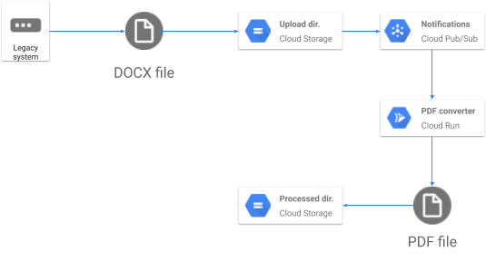

## Using Googleapis

During this lab you will use Google APIs. The following APIs have been enabled for you:

|  |  |
| --- | --- |
| **Name** | **API** |
| Cloud Build | cloudbuild.googleapis.com |
| Cloud Storage | storage-component.googleapis.com |
| Cloud Run | run.googleapis.com |

## Get the source code

Get started by downloading the code necessary for this lab.

1. Activate your lab account:

gcloud auth list --filter=status:ACTIVE --format="value(account)"

content_copy

1. Run the following to clone the Pet Theory repository:

git clone https://github.com/Deleplace/pet-theory.git

content_copy

1. Move to the correct directory:

cd pet-theory/lab03

content_copy

## Creating an invoice microservice

In this section you will create a Go application to process requests. As outlined in the architecture diagram, you will integrate Cloud Storage as part of the solution.

Open the server.go source code and edit it to match the text below:

package main

import (

"fmt"

"io/ioutil"

"log"

"net/http"

"os"

"os/exec"

"regexp"

"strings"

)

func main() {

http.HandleFunc("/", process)

port := os.Getenv("PORT")

if port == "" {

port = "8080"

log.Printf("Defaulting to port %s", port)

}

log.Printf("Listening on port %s", port)

err := http.ListenAndServe(fmt.Sprintf(":%s", port), nil)

log.Fatal(err)

}

func process(w http.ResponseWriter, r *http.Request) {

log.Println("Serving request")

if r.Method == "GET" {

fmt.Fprintln(w, "Ready to process POST requests from Cloud Storage trigger")

return

}

//

// Read request body containing GCS object metadata

//

gcsInputFile, err1 := readBody(r)

if err1 != nil {

log.Printf("Error reading POST data: %v", err1)

w.WriteHeader(http.StatusBadRequest)

fmt.Fprintf(w, "Problem with POST data: %v \n", err1)

return

}

//

// Working directory (concurrency-safe)

//

localDir, errDir := ioutil.TempDir("", "")

if errDir != nil {

log.Printf("Error creating local temp dir: %v", errDir)

w.WriteHeader(http.StatusInternalServerError)

fmt.Fprintf(w, "Could not create a temp directory on server. \n")

return

}

defer os.RemoveAll(localDir)

//

// Download input file from GCS

//

localInputFile, err2 := download(gcsInputFile, localDir)

if err2 != nil {

log.Printf("Error downloading GCS file [%s] from bucket [%s]: %v",

gcsInputFile.Name, gcsInputFile.Bucket, err2)

w.WriteHeader(http.StatusInternalServerError)

fmt.Fprintf(w, "Error downloading GCS file [%s] from bucket [%s]",

gcsInputFile.Name, gcsInputFile.Bucket)

return

}

//

// Use LibreOffice to convert local input file to local PDF file.

//

localPDFFilePath, err3 := convertToPDF(localInputFile.Name(), localDir)

if err3 != nil {

log.Printf("Error converting to PDF: %v", err3)

w.WriteHeader(http.StatusInternalServerError)

fmt.Fprintf(w, "Error converting to PDF.")

return

}

//

// Upload the freshly generated PDF to GCS

//

targetBucket := os.Getenv("PDF_BUCKET")

err4 := upload(localPDFFilePath, targetBucket)

if err4 != nil {

log.Printf("Error uploading PDF file to bucket [%s]: %v", targetBucket, err4)

w.WriteHeader(http.StatusInternalServerError)

fmt.Fprintf(w, "Error downloading GCS file [%s] from bucket [%s]",

gcsInputFile.Name, gcsInputFile.Bucket)

return

}

//

// Delete the original input file from GCS.

//

err5 := deleteGCSFile(gcsInputFile.Bucket, gcsInputFile.Name)

if err5 != nil {

log.Printf("Error deleting file [%s] from bucket [%s]: %v", gcsInputFile.Name,

gcsInputFile.Bucket, err5)

// This is not a blocking error.

// The PDF was successfully generated and uploaded.

}

log.Println("Successfully produced PDF")

fmt.Fprintln(w, "Successfully produced PDF")

}

func convertToPDF(localFilePath string, localDir string) (resultFilePath string, err error) {

log.Printf("Converting [%s] to PDF", localFilePath)

cmd := exec.Command("libreoffice", "--headless", "--convert-to", "pdf",

"--outdir", localDir,

localFilePath)

cmd.Stdout, cmd.Stderr = os.Stdout, os.Stderr

log.Println(cmd)

err = cmd.Run()

if err != nil {

return "", err

}

pdfFilePath := regexp.MustCompile(`\.\w+$`).ReplaceAllString(localFilePath, ".pdf")

if !strings.HasSuffix(pdfFilePath, ".pdf") {

pdfFilePath += ".pdf"

}

log.Printf("Converted %s to %s", localFilePath, pdfFilePath)

return pdfFilePath, nil

}

content_copy

Now run the following to build the application:

go build -o server

content_copy

The functions called by this top-level code are in source files:

* server.go
* notification.go
* gcs.go

With the application has been successfully built, you can create the pdf-conversion service.

## Create a pdf-conversion service

The PDF service will use Cloud Run and Cloud Storage to initate a process each time a file is uploaded to the designated storage.

To achieve this you will use a common pattern of event notifications together with Cloud Pub/Sub. Doing this enables the application to concentrate only on processing information. Transporting and passing information is performed by other services, which allows you to keep the application simple.

Building the invoice module requires the integration of two components:

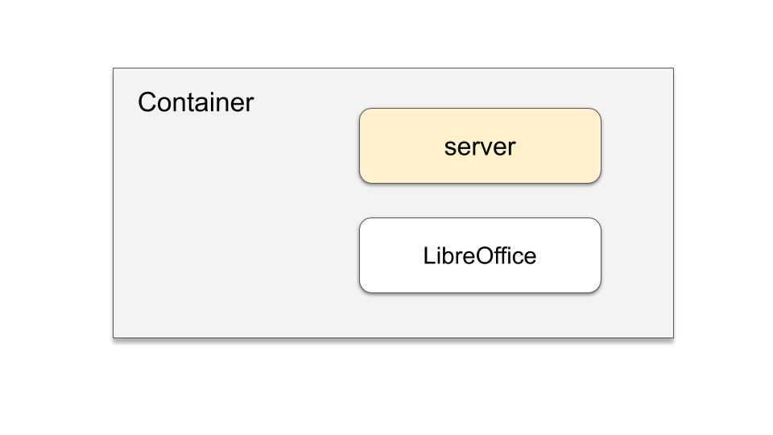

Adding the LibreOffice package means it can be used in your application.

1. Open the existing Dockerfile manifest and update the file as shown below:

FROM debian:buster

RUN apt-get update -y \

&& apt-get install -y libreoffice \

&& apt-get clean

WORKDIR /usr/src/app

COPY server .

CMD [ "./server" ]

content_copy

1. **Save** the updated Dockerfile.
2. Initiate a rebuild of the pdf-converter image using Cloud Build:

gcloud builds submit \

--tag gcr.io/$GOOGLE_CLOUD_PROJECT/pdf-converter

content_copy

Click **Check my progress** to verify that you've performed the above task.

Build an image with Cloud Build

Check my progress

1. Deploy the updated pdf-converter service.

**NOTE:** It's a good idea to give LibreOffice 2GB of RAM to work with, see the line with the --memory option.

Run these commands to build the container and to deploy it:

gcloud run deploy pdf-converter \

--image gcr.io/$GOOGLE_CLOUD_PROJECT/pdf-converter \

--platform managed \

--region us-central1 \

--memory=2Gi \

--no-allow-unauthenticated \

--set-env-vars PDF_BUCKET=$GOOGLE_CLOUD_PROJECT-processed

content_copy

Click **Check my progress** to verify that you've performed the above task.

PDF Converter service deployed

Check my progress

The Cloud Run service has now been successfully deployed. However we deployed an application that requires the correct permissions to access it.

## Create a Service Account

A [Service Account](https://cloud.google.com/iam/docs/understanding-service-accounts) is a special type of account with access to Google APIs.

In this lab uses a Service Account to access Cloud Run when a Cloud Storage event is processed. Cloud Storage supports a rich set of notifications that can be used to trigger events.

Next, update the code to notify the application when a file has been uploaded.

1. Click the **Navigation menu** > **Storage**, and verify that two buckets have been created. You should see:

* PROJECT_ID-processed
* PROJECT_ID-upload

1. Create a Pub/Sub notification to indicate a new file has been uploaded to the docs bucket ("uploaded"). The notifications will be labeled with the topic "new-doc".

gsutil notification create -t new-doc -f json -e OBJECT_FINALIZE gs://$GOOGLE_CLOUD_PROJECT-upload

content_copy

1. Create a new service account to trigger the Cloud Run services:

gcloud iam service-accounts create pubsub-cloud-run-invoker --display-name "PubSub Cloud Run Invoker"

content_copy

1. Give the service account permission to invoke the PDF converter service:

gcloud run services add-iam-policy-binding pdf-converter \

--member=serviceAccount:pubsub-cloud-run-invoker@$GOOGLE_CLOUD_PROJECT.iam.gserviceaccount.com \

--role=roles/run.invoker \

--region us-central1 \

--platform managed

content_copy

1. Find your project number by running this command:

PROJECT_NUMBER=$(gcloud projects list \

--format="value(PROJECT_NUMBER)" \

--filter="$GOOGLE_CLOUD_PROJECT")

content_copy

1. Enable your project to create Cloud Pub/Sub authentication tokens:

gcloud projects add-iam-policy-binding $GOOGLE_CLOUD_PROJECT \

--member=serviceAccount:service-$PROJECT_NUMBER@gcp-sa-pubsub.iam.gserviceaccount.com \

--role=roles/iam.serviceAccountTokenCreator

content_copy

Click **Check my progress** to verify that you've performed the above task.

Service Account created

Check my progress

With the Service Account created it can be used to invoke the Cloud Run Service.

## Testing the Cloud Run service

Before progressing further, test the deployed service. Remember the service requires authentication, so test that to ensure it is actually private.

1. Save the URL of your service in the environment variable **$SERVICE_URL**:

SERVICE_URL=$(gcloud run services describe pdf-converter \

--platform managed \

--region us-central1 \

--format "value(status.url)")

content_copy

1. Display the SERVICE URL:

echo $SERVICE_URL

content_copy

1. Make an anonymous GET request to your new service:

curl -X GET $SERVICE_URL

content_copy

The anonymous GET request will result in an error message "Your client does not have permission to get URL". This is good; you don't want the service to be callable by anonymous users.

1. Now try invoking the service as an authorized user:

curl -X GET -H "Authorization: Bearer $(gcloud auth print-identity-token)" $SERVICE_URL

content_copy

1. You will get the response "Ready to process POST requests from Cloud Storage trigger"

Great work, you have successfully deployed an authenticated Cloud Run service.

## Cloud Storage trigger

To initiate a notification when new content is uploaded to Cloud Storage, add a subscription to your existing Pub/Sub Topic.

**Remember:** Cloud Storage notifications will automatically push a message to your Topic queue when new content is uploaded. Using notifications allows you to create powerful applications that respond to events without needing to write additional code.

Create a Pub/Sub subscription so that the PDF converter will be run whenever a message is published to the topic new-doc:

gcloud pubsub subscriptions create pdf-conv-sub \

--topic new-doc \

--push-endpoint=$SERVICE_URL \

--push-auth-service-account=pubsub-cloud-run-invoker@$GOOGLE_CLOUD_PROJECT.iam.gserviceaccount.com

content_copy

Click Check my progress to verify that you've performed the above task.

Confirm Pub/Sub Subscription

Check my progress

Now whenever a file is uploaded the Pub/Sub subscription will interact with your Service Account. The Service Account will then initiate your PDF Converter Cloud Run service.

## Testing Cloud Storage Notification

To test the Cloud Run service, use the example files available.

1. Copy the test files into your upload bucket:

gsutil -m cp -r gs://spls/gsp762/* gs://$GOOGLE_CLOUD_PROJECT-upload

content_copy

1. In the Cloud Console, look in the Cloud Storage **upload** bucket and click the **Refresh bucket** button a few times and see how the files are deleted, one by one, as they are converted to PDFs. Then click **Storage**, followed by the bucket whose name ends in "-processed". It should contain PDF versions of all files. Feel free to open the PDF files to make sure they were properly converted.
2. Once the upload is done, use the **Navigation menu** to go to the **Cloud Run** and click on the **pdf-converter** service.

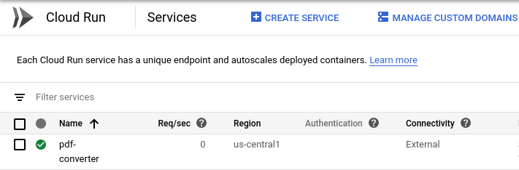

1. Select the **LOGS** tab and add a filter of "Converting" to see the converted files.

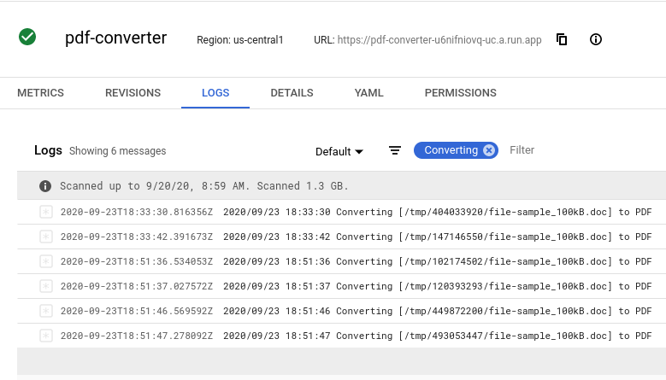

1. From the **Navigation menu** go to **Storage** and open the "upload" folder and confirm all files uploaded have been processed.

Excellent work, you have successfully built a new service to create a PDF using files uploaded to Cloud Storage.